Lesson 1: A Trader's Introduction to the British Pound
In our last lesson we finished up our discussion of the Japanese Yen with a look at some of the major factors which move the currency, as well as where traders can go to find out more information on those indicators. In today's lesson we are going to discuss the 4th most actively traded currency in the world, the British Pound.
Although the United Kingdom is a member of the European Union, it has not yet adopted the Euro as its currency, so it is not part of the European Monetary Union. There are a number of reasons for this, but perhaps most famous is the country's forced withdrawal from the Exchange Rate Mechanism, the precursor to the Euro. As we have touched on in previous lessons, before joining the Euro countries were required to meet certain criteria, one of which was to keep the value of their currency within certain "bands". After initially trying to adhere to the qualifications set forth for participation in the European Monetary Union, the value of the pound dropped below the lower band, forcing the country out of what would become the European Monetary Union. Although the Prime Minister as of this lesson, Gordon Brown, has ruled out joining the European Monetary Union for the foreseeable future, many feel that the UK will eventually adopt the Euro, and therefore any such talk can have an affect on the pound.
The former Prime Minister of the United Kingdom laid out 5 broad economic tests that must be passed, before the UK would consider adopting the Euro. These would of course be in addition to the requirements set forth in the Maastricht treaty, which we learned about in our lesson on the Euro.
The five tests according to Wikipedia.org are:
1. Are business cycles and economic structures compatible so that the UK and others could live comfortable with Euro interst rates on a permanent basis?
2. If problems emerge is there sufficient flexibility to deal with them?
3. Would joining the EMU create better conditions for firms making long-term decisions to invest in britain.
4. What impact would entry into the EMU have on the competitive position of the UK's financial services industry, particularly the city's wholesale markets?
5. In summary, will joining the EU promote higher growth, stability, and a lasting increase in jobs?
In addition to these factors, the UK economy is a service based economy, with a heavy emphasis on financial services, and is a net exporter of oil and natrual gas, so energy prices will affect the currency.
As Kathy Lien points out in her book Day Trading the Currency Market, while the GBP/USD is a very active currency, the Pound is also very active in the crosses, and as the EU is their largest trading partner, traders pay particular attention to movements in the EUR/GBP for fundamental ques on the currency. As of this lesson the UK also has the highest interest rates in the G7, causing it to be used as the currency many traders will buy when playing the carry trade we learned about in module 3 of this course. This makes GBP/JPY one of the more active crosses in the market and one which traders who are looking for increased volatility often choose as their favorite.
Like the other currencies which we have studied, fxwords.com offers a great page listing all the indicators which move the currency, their definition, and relative importance to the market which you can find a link to below this video. This, along with the global calendar which you can find at the top of Dailyfx.com, provides a great overview and release times for all the major indicators which move the market.
Thats our lesson for today. In our next lesson we are going to look at the world's safe haven currency the Swiss Franc so we hope to see you in that lesson.

Lesson 2: A Trader's Introduction to the Swiss Franc
In our last lesson we continued our free forex trading course with a look at the British Pound. In today's lesson we are going to look at the fifth most actively traded currency in the world, the Swiss Franc.
Switzerland is one of the richest countries in the world, and while its economic policies and practices largely conform with EU standards, the country's population rejected accession negotiations with the EU in March of 2001. So, at least for the foreseeable future, the Swiss Franc is expected to remain one of the world's most actively traded currencies, with two dominating features that are important to us as forex traders.
Although this status has started to wane somewhat in recent years, the Swiss Franc has historically been considered one of the world's primary safe haven currencies, which means that money flows into the Swiss Franc during times of economic or geopolitical uncertainty. The primary reasons why this is the case are:
1. The country's ability to remain out of Global Conflicts, a reputation it solidified by remaining neutral during both World Wars.
2. Its economic stability and relatively low inflation rates.
3. The fact that up until recently the currency was 40% backed by gold.
4. Its reputation for high quality financial institutions and banking secrecy.
As you can see from this chart, traders who anticipated the Swiss Franc would strengthen as a result of its safe haven status, could have participated in the 1251 pip move lower in USD/CHF, in the 10 days following the September 11th 2001 attacks.
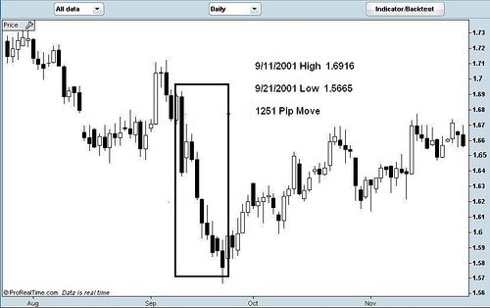
As another example of the Swiss Franc displaying its safe haven tendencies, traders who anticipated that the Swiss Franc would strengthen as a result of the US Invasion of Iraq, could have participated in another 1200+ pip move in the USD/CHF in the 2 months following the invasion.
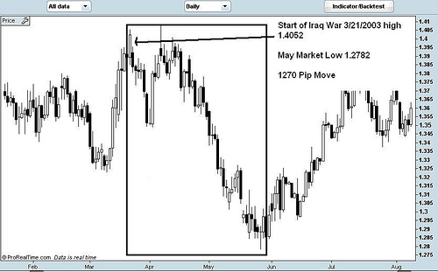
In 2005 the Swiss government sold the nations vast gold inventory, and as a result the currency is no longer backed by gold. Some argue that because of this the Swiss Franc has lost much of its safe haven status, something that there will surely be more tests of in the years to come.
The second thing that it is important for traders to understand about the Swiss Franc, is its strong correlation with the Euro. As the Swiss Franc is quoted on the opposing side of the Dollar when compared to the Euro, this means that the USD/CHF currency pair has a strong negative correlation with the EUR/USD currency pair, as you can see from this chart:
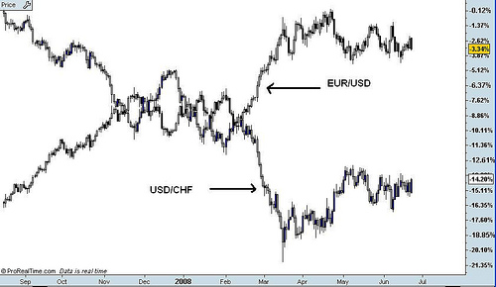
As you can see here a chart of the two currency pairs shows the strong negative correlation of over 90% between the two currency pairs, resulting from the strong economic ties between Switzerland and the European Union.
The first reason that it is important for traders to understand this strong negative correlation, is so that they can take it into account when considering trades in both currency pairs. As the two currency pairs have such a high negative correlation, there is a very good possibility that a trader's technical analysis will show a buy signal in the EUR/USD, while at the same time showing a sell signal USD/CHF, or vice versa.
If this trader happened to be blind to the negative correlation we have just outlined, he or she may think that they are putting on two completely different trades. As we have just shown however, what this trader would actually be doing is doubling their exposure to the move they were trying to capture. Conversely, if a trader were to trade these pairs in the same direction, then they would effectively be reducing the potency of both trades, as the negative correlation between the two currency pairs will act to offset the gains or losses that result on each trade.
As the Swiss Franc is no where near as liquid as the Euro, on an intraday basis it is important to be aware that this negative correlation can breakdown some what. Lastly, should the Swiss political and/or economic environment (especially monetary policy) start to substantially diverge from that of the Eurozone, you could see a breakdown of this negative correlation on the longer timeframes as well.
As with the other currency pairs we are studying, FXWords.com has a great page outlining the details of all the important economic indicators for the Franc, a link to which you can find below this video. The Global Calendar at Dailyfx.com also gives you the release dates and realtime analysis of those releases, so you can be aware of them and follow the results in real time there as well.
That's our lesson for today, in our next lesson we will begin a series on the commodity currencies, starting with the Canadian Dollar, so we hope to see you in that lesson.

Lesson 3: A Trader's Introduction to the Canadian Dollar
In our last lesson we continued our free forex trading course, with a look at the major factors that affect the Swiss Franc. In today's lesson we are going to begin a discussion of the world's main commodity currencies, starting with a look at the Canadian Dollar.
There are two dominant themes that it is important to understand when analyzing the Canadian Dollar from a fundamental standpoint. The first, as its designation as a commodity currency implies, is the fact that exports of natural resources (especially gold and oil) make up a significant part of the Canadian economy. This is important to understand because as Canada is the world's 14th largest producer of oil and 5th largest producer of gold, the price of these and other commodities normally has a direct affect on the Canadian Dollar's Exchange rate.
The second thing that it is important to understand here, is the fact that as the Canadian population is relatively small in comparison to its land mass, the economy is heavily reliant on exports, which ties the country more closely together with the international economy as a whole. This is particularly true in regards to economy of the United States, as the US is Canada's largest trading partner, and 81% of Canadian Exports flow to the US.
While many people believe that the US relies most heavily on the middle east for its oil imports, it is actually Canada that is the largest supplier of oil to the United States. As the US is the world's largest oil consumer and Canada is one of the largest producers, fluctuations in the price of oil have double the impact. As we learned in our lesson on trade flows, as the US is a net oil importer and Canada is a net oil exporter, then all else being equal, a rise in the price of oil should strengthen the CAD and weaken the USD.
While exports of commodities are still a very important component of the Canadian economy, the country's service sector has experienced massive growth in recent decades, to the point where the service industry now accounts for 2/3rds of the country's economic output. This is important to understand because, as the United States is its largest trading partner, a slowdown in the US Economy can hurt the Canadian economy and its currency, even if commodity prices remain high.
As with the other currencies we have looked at, in the interest of maximizing our learning, I am going to defer to FXwords.com for an overview of the country's primary economic indicators. I have included a link to the Canadian economic indicators page on FXwords below this video on InformedTrades.com which provides a detailed overview of each, as well as their relative importance to the market. For a snapshot of when each of these indicators is released, as well as what analysts forecasts for the release are, I encourage you to use the global calendar which you can find at the top of Dailyfx.com.
That's our lesson for today. In our next lesson we will continue our discussion of the commodity currencies, with a look at the Australian Dollar so I hope to see you in that lesson.

Lesson 4: A Trader's Introduction to the Australian Dollar
In our last lesson we continued our free forex course with a look at the important fundamental factors which affect the Canadian Dollar. In today's lesson we are going to continue our discussion of the world's main commodity currencies, with a look at the Australian Dollar.
Like Canada, Australia's economy is a service based economy, with over 68% of GDP coming from the service sector. Although agriculture and mining account for only 4.7% of Australian GDP, they account for over 65% of the country's exports. This makes the currency highly sensitive to increases or decreases in the price of commodities, especially gold, as Australia is the world's 3rd largest exporter of gold.
While the country and currency are similar to Canada in many ways, a primary difference is the trade relationships that Australia has developed with Asia, and in particular Japan and China, which represent its two largest export markets. This gives the currency a unique exposure to Asia, which generally does not exist with the other non Asian currencies we have studied up to this point.
As Kathy Lien points out in her book Day Trading the Currency Market, the Australian economy was able to whether the Asian financial crisis relatively well, so while there is exposure there, it is also important to keep a watch on the country's historically strong domestic consumption, in times of global economic slowdowns.
The last major factor to keep in mind about the Australian Dollar, is that Australia has one of the highest interest rates in the developed world, currently at 7.25% as of this lesson. This has made the currency one of the primary beneficiaries of carry trade flows, which we learned about in my 3 part series on the carry trade, in module 3 of this course. These flows, combined with the facts that many commodities that Australia exports are at all time highs, and the Australian economy has remained relatively strong through the current crisis, has moved the AUD/USD to 25 year highs as of this lesson.
AUD/USD Monthly:
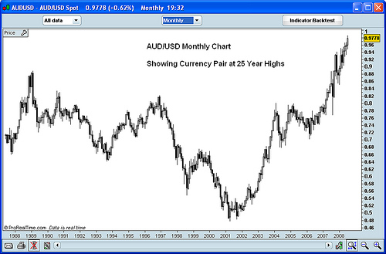
As with the other currencies we have studied, in the interest of maximizing our learning I am going to defer to FXword's Australian economic indicator page for more information on the important Australian economic indicators. I have included a link to this page below this video on InformedTrades, where you can find definitions of each, as well as their relative importance to the market. For updates on when these indicators are released, as well as what the market is expecting from them, I recommend checking out the global calendar at Dailyfx.com which you can find at the top of the homepage.
That's our lesson for today. In our next lesson we will finish up our discussion of the commodity currencies and the main currency pairs with a look at the New Zealand Dollar, so I hope to see you in that lesson.

Lesson 5: A Trader's Introduction to the New Zealand Dollar
In our last lesson we continued our discussion of the world's main commodity currencies with a look at the major fundamental factors which affect the Australian Dollar. In today's lesson we are going to wrap up our discussion on commodity currencies as well as our modules on profiles of the worlds main currencies, with a look at the New Zealand Dollar.
According to Wikipedia.org, New Zealand has a 2008 estimated population of around 4.2 million people, which is the first important fact for us to understand for two reasons. Firstly, as New Zealand's domestic market is so small, it must rely heavily on exports to drive economic growth, making the country especially susceptible to growth or decline in the global economy.
This is particularly true when looking at the health of its main trading partners, the largest of which is Australia, followed by the United States, and Japan. Secondly, unlike other countries with a larger population, as the population of New Zealand is small, migration of people into and out of the country can have a significant effect on its economy, and therefore the currency. As Kathy Lien points out in her book Day Trading the Currency Market, strong population migration into New Zealand has contributed significantly to the performance of its economy, because as the population increases, so does domestic consumption.
Like Canada and Australia, New Zealand is a country with vast natural resources, making the economy and therefore currency heavily reliant on exports of commodities such as Wool, food and dairy products, wood and paper products. As Australia is the country's main export market and as the Australian Dollar is also heavily influenced by commodity prices, changes in commodity prices can have a particularly potent affect on the New Zealand Dollar. Although this correlation has broken down somewhat in recent months, as you can see from this chart, the NZD/USD and AUD/USD currency pairs are highly correlated as a result of these factors:
Chart Showing NZD/USD and AUD/USD Correlations:
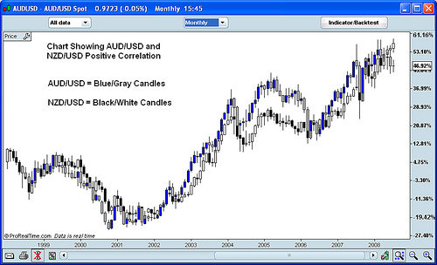
The last major fundamental factor that it is important to keep in mind when trading the New Zealand Dollar is, like the Australian Dollar here again, New Zealand, as of this lesson, has one of the highest interest rates in the industrialized world currently at 8.25%. This has driven the NZD/USD pair to 25 year highs recently, before selling off a bit as a result of slower growth in the New Zealand. This is important to keep in mind, as the currency has been one of the primary beneficiaries of the carry trade flows we learned about in module 3 of this course, so interest rate expectations going forward will weigh heavily on the future direction of the currency.
Thats our lesson for today, and that wraps up our lessons on the commodity currencies, and other main currencies of the world.

