Lesson 1: A Traders Introduction to the Yen, Part I
In our last lesson we finished up our discussion on the Euro, with a look at the major economic indicators which affect the currency, and where traders can go to follow those indicators. In today's lesson we are going to continue our free forex trading course, with a look at the next most actively traded currency in the world, the Japanese Yen.
.
Japan has the second largest economy in the world behind the United States, and an economic history that is the starting point for understanding the fundamentals of the Yen. The first thing that it is important to understand from a fundamental standpoint about the Japanese economy, is that unlike the United States, Japan has very few natural resources. As a result of this, prior to World War II, Japan had a large military force, which it used to occupy Korea, Taiwan, and parts of China. The country saw this as necessary, because of the vulnerable position that its lack of natural resources would have otherwise put it into.
Like with Europe however, World War II, set the country back considerably from an economic standpoint, as according to wikipedia.org, 40% of its industrial plants and infrastructure were destroyed. While no one would obviously wish for that type of destruction, there was actually a silver lining in this for the Japanese Economy. As so much of their infrastructure had been destroyed, this gave the Japanese the ability to upgrade it significantly, ultimately giving them an edge over victor states, who now had much older factories.
After World War II the United States occupied Japan, which resulted in the building of a democratic nation, that was dominated by industry, instead of the military. As the Japanese were now putting all of the focus, which had before been put into the military, into rebuilding their industries, they were able to not only match their pre war production levels by 1950, but surpass them. In the decades that followed Japan proved very competitive on the international stage, and its economic growth in the 60's, 70's and 80's has been described as nothing short of astonishing.
If you were around living in the US during the 80's, you can probably remember the envy and fear among the US population, that Japan was quickly going to overcome the United States as the world's economic power house.
While I don't think there is any question that the quality of Japanese products and services has remained very high since the 80's, unfortunately Japan's economy derailed in the early 1990's, culminating in the busting of one of the most famous asset price bubbles in history.
In the decades following World War II the Japanese population had one of the highest savings rates in the world. As more money was being saved, this meant there was more money available for investment, making access to credit much easier than it had been in the past. As Japan's economy was and still is an export oriented economy, the value of the currency also went up dramatically during this time. The combination of a strong economy, easy access to credit, and a strengthening currency made Japanese assets especially attractive.
As its economy seemed unstoppable, and newly wealthy Japanese saved more and more money, much of that capital flowed into the stock and real estate markets. As you can see from this chart the stock market roared through the 1980s, almost quadrupling in value in 5 years. In the most expensive districts, according to wikipedia.org, real estate prices reached as high as $139,000 per square foot.
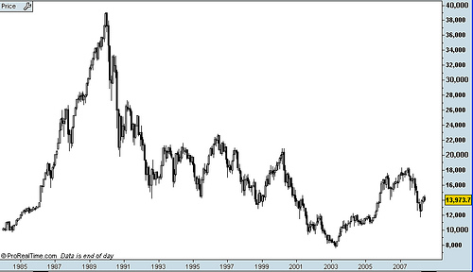
From the high of the stock and real estate markets in 1990, both markets made a slow and painful decline. It took until 2003 for the stock market to finally bottom, down from a top of around 39,000 to a bottom of around 7600. According to wikipedia.org, prices for the most expensive commercial real estate properties stood at 1/100th of their pre bubble bursting peak, and $20 Trillion in wealth had been wiped out in the stock and real estate markets.
While this may seem like a history lesson that is not relevant to traders, as we will learn in tomorrow's lesson, the affects of Japan's asset price bubble on the Yen are still being felt today, and therefore an understanding is necessary to know how today's market will react to different fundamental events.
That's our lesson for today. In tomorrow's lesson we will look at the long road to recovery that Japan is still traveling down today, how this affects their monetary policy, and therefore the value of their currency.

Lesson 1: A Traders Introduction to the Yen, Part I
In our last lesson we finished up our discussion on the Euro, with a look at the major economic indicators which affect the currency, and where traders can go to follow those indicators. In today's lesson we are going to continue our free forex trading course, with a look at the next most actively traded currency in the world, the Japanese Yen.
.
Japan has the second largest economy in the world behind the United States, and an economic history that is the starting point for understanding the fundamentals of the Yen. The first thing that it is important to understand from a fundamental standpoint about the Japanese economy, is that unlike the United States, Japan has very few natural resources. As a result of this, prior to World War II, Japan had a large military force, which it used to occupy Korea, Taiwan, and parts of China. The country saw this as necessary, because of the vulnerable position that its lack of natural resources would have otherwise put it into.
Like with Europe however, World War II, set the country back considerably from an economic standpoint, as according to wikipedia.org, 40% of its industrial plants and infrastructure were destroyed. While no one would obviously wish for that type of destruction, there was actually a silver lining in this for the Japanese Economy. As so much of their infrastructure had been destroyed, this gave the Japanese the ability to upgrade it significantly, ultimately giving them an edge over victor states, who now had much older factories.
After World War II the United States occupied Japan, which resulted in the building of a democratic nation, that was dominated by industry, instead of the military. As the Japanese were now putting all of the focus, which had before been put into the military, into rebuilding their industries, they were able to not only match their pre war production levels by 1950, but surpass them. In the decades that followed Japan proved very competitive on the international stage, and its economic growth in the 60's, 70's and 80's has been described as nothing short of astonishing.
If you were around living in the US during the 80's, you can probably remember the envy and fear among the US population, that Japan was quickly going to overcome the United States as the world's economic power house.
While I don't think there is any question that the quality of Japanese products and services has remained very high since the 80's, unfortunately Japan's economy derailed in the early 1990's, culminating in the busting of one of the most famous asset price bubbles in history.
In the decades following World War II the Japanese population had one of the highest savings rates in the world. As more money was being saved, this meant there was more money available for investment, making access to credit much easier than it had been in the past. As Japan's economy was and still is an export oriented economy, the value of the currency also went up dramatically during this time. The combination of a strong economy, easy access to credit, and a strengthening currency made Japanese assets especially attractive.
As its economy seemed unstoppable, and newly wealthy Japanese saved more and more money, much of that capital flowed into the stock and real estate markets. As you can see from this chart the stock market roared through the 1980s, almost quadrupling in value in 5 years. In the most expensive districts, according to wikipedia.org, real estate prices reached as high as $139,000 per square foot.
From the high of the stock and real estate markets in 1990, both markets made a slow and painful decline. It took until 2003 for the stock market to finally bottom, down from a top of around 39,000 to a bottom of around 7600. According to wikipedia.org, prices for the most expensive commercial real estate properties stood at 1/100th of their pre bubble bursting peak, and $20 Trillion in wealth had been wiped out in the stock and real estate markets.
While this may seem like a history lesson that is not relevant to traders, as we will learn in tomorrow's lesson, the affects of Japan's asset price bubble on the Yen are still being felt today, and therefore an understanding is necessary to know how today's market will react to different fundamental events.
That's our lesson for today. In tomorrow's lesson we will look at the long road to recovery that Japan is still traveling down today, how this affects their monetary policy, and therefore the value of their currency.

Lesson 3: A Traders Introduction to the Yen, Part III
In our last lesson continued our discussion on the Japanese Yen, with a look at what happened to the Yen and Japan's economy after their asset price bubble began to burst in 1990, and how this still affects the currency today. In today's lesson we are going to wrap up our discussion on the Yen, with a look at Bank of Japan Intervention, and other fundamental factors which move the currency.
As we touched on in our first lesson in this series, Japan has few natural resources of their own, so they are an economy that relies heavily on imports of natural resources such as oil. This is something to keep in mind when trading the currency, because as Japan imports almost 100% of its oil from overseas, increases and decreases in the price of oil will normally have an affect on the value of the Yen.
The second thing that it is important to keep in mind, is that the Japanese economy relies heavily on exports such as cars and electronics to grow their economy. As a result of this, the value of Japan's currency is an even more important factor in their economic growth than for countries which do not rely so heavily on exports to drive domestic growth. As we learned about in our lessons on trade flows, a stronger Yen automatically means that Japanese goods and services become more expensive for overseas consumers, which will hurt Japanese exports.
To keep the Yen from rising to the point where it would hurt the Japanese economy, the Bank of Japan is notorious for intervening in the foreign exchange markets, which can send the value of the yen plummeting.
Below is a graph provided by Dailyfx.com which shows some of the history of Japanese intervention, which as you can see tends to take place around the 100 level in the currency. As the BOJ has been so effective with intervention in the past, it has gotten to the point now where all they need to do is talk of intervention (something called verbal intervention) to yen based pairs rocketing higher.
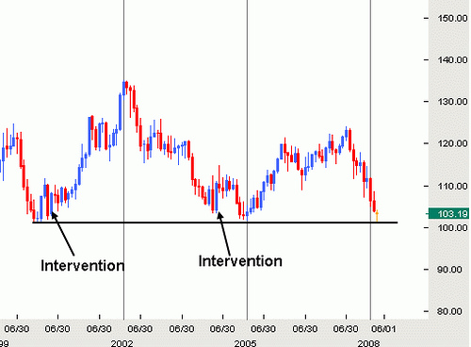
As with all the currency pairs we are studying, there are many economic indicators which affect the value of the yen, that we could spend much time discussing. As we have already covered the major indicators for the US in module 8 of our basics of trading course, and as the indicators in Japan are much the same, in the interest of maximizing our learning time I am going to point you towards two free sites for more information.
The first is FX Words Trading Glossary and their economic indicators page for Japan the link to which you can find below this video. As you can see here they provide not only the definition of each of the major releases but also the importance of the indicator to the market.
The second site is the global calander which you can find by clicking the calendar button at the top of dailyfx.com. As you can see here in addition to giving you the importance of the indicator, they also give you the time it is schedualed for release, the forcast, and where you can go to find out more information.
Thats our lesson for today and that wraps up our three lesson series on the Japanese Yen. In our next lesson we will start a new series on trading the British Pound so we hope to see you in that lesson.

