Lesson 1: Position Sizing Separates the Winners
So far in the lessons leading up to this one we have covered some of the different methods traders use to pick their entry points, as well as some of the different methods which traders use to set their exit points. In this lesson we are going to look at the factor which ties all of the above together and allows a trader the greatest control over their returns: Position Sizing.
While position sizing is one of the Key components of successful trading, like many of the other things we have covered, it is often overlooked as an unimportant aspect of trading. What successful traders know however is that once the psychology of trading is mastered and a trader has developed a sound strategy for picking their entry and exit points, it is the method they use to determine the size of the positions they trade that is the final factor which will lead to their success or failure.
To help illustrate this lets say that three traders are each given $10,000 and the same EUR/USD Mini Forex strategy to trade which has a win rate of 60% (makes a profit on 6 out of 10 trades) and makes an average profit on winning trades over the long term of 100 Points. On the losing side, this same system has a lose rate of 40% (takes a loss on 4 out of 10 trades) and takes an average loss on those trades of 90 points.
So here we have a trading strategy that has more winning trades on average than it does losing trades, as well as a strategy that when it does lose it loses less than what it does when it wins. I think most traders including myself would take that system any day of the week.
So we give these traders each this system and tell them to come back to us after 10 trades and show their results. As the system is the same for all traders, when they bring us back the trading results of their systems the entry points and exit points for each trade is going to be the same, leaving them only the position size as the factor that they can tweak.
As they are trading mini EUR/USD forex contracts the value of a 1 point move is $1 per contract traded. With this in mind after 10 trades the system produces the following results:
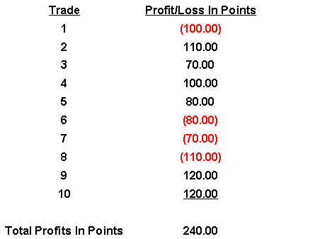
So Trader 1 recently read an interview of a successful trader who said that one of the major reasons why forex trading has such a bad name is that people over leverage themselves. In this interview the trader recommended not leveraging more than 20 to 1. So with this in mind the trader decides that since this is a winning system he is going to take it to the max that this trader recommended and trade 5 mini forex contracts (50,000) on each trade since he is starting with $10,000.
With this in mind his results are the following:
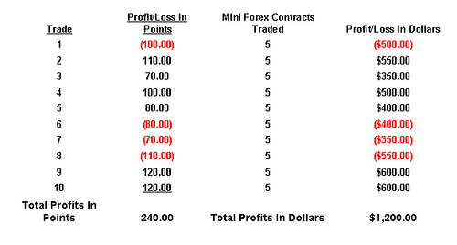
Trader 2 decides that since the strategy is one of the best he has seen he is going to be more aggressive than trader 1 and trade 10 contracts (100,000) on each trade. This produces the following results.
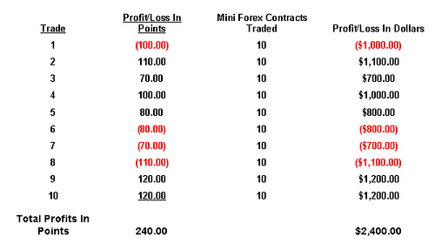
As you can see here by doubling the number of contracts that he traded on each trade trader 2 doubled the returns of trader 1.
Trader 3 decides that since the system is a guaranteed winner he is going to leverage up as much as he can and swing for the fences on every trade thinking that this will produce the maximum gain at the end of the 10 Trades. This produces the following results.
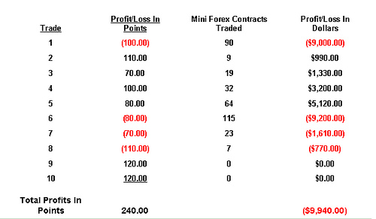
As you can see here because he had such a large trade on and the first trade was a loser, he now had very little money left after the first trade and therefore could not trade as many contracts. Continuing with the strategy though the trader kept swinging for the fences on every trade until he was basically at the point where he did not have enough money in his account to initiate a new position for the 9th and 10th trades.
As I hope the above examples of three traders given the same strategy can produce drastically different results based on the position size they take with each trade, and thus shows the importance that position sizing plays in any successful strategy. In tomorrow’s lesson we are going to look at some of the different strategies many traders use to determine their position size so we hope to see you in that lesson.

Lesson 2: The Problem With Fixed Position Sizes
In yesterday’s lesson we introduced another important yet often overlooked aspect of trading and money management strategies which is position sizing. In today’s lesson we are going to begin to look at some of the strategies that many successful traders use to determine their position sizes.
As we discussed briefly in the last lesson many traders make the mistake of choosing an arbitrary number such as 1 contract or 100 shares of stock to trade when they first enter the market. In addition to the fact that this does not consider the amount of capital a trader has at his disposal, it also does not take into account the fact that the Dollar value as well as the volatility characteristics of one contract or 100 shares of stock is going to vary greatly. Like a poker player who bets the same amount on every hand, this also does not allow a trader the flexibility to trade bigger on trades with a higher probability of success and smaller on trades with a lower probability of success.
As you can see from the picture below, a trader trading 100 shares of a $20 stock which fluctuates 5% a day and a second position of 100 shares of a $30 stock which fluctuates 1% a day does not present the risk/reward picture that many traders would expect it would. In this example the smaller position actually has a greater potential risk and reward because of the greater volatility of the first stock in the example.
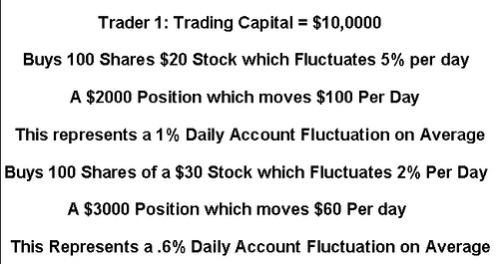
The next level of sophistication up from the above, is trading a standard trade size such as 1 contract or 100 shares of stock for every fixed amount of money.
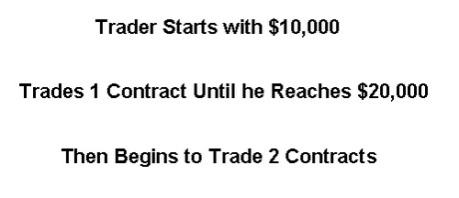
As Dr. Van K. Tharp points out however in his book Trade Your Way to Financial Freedom, there are several distinct disadvantages to using this method which are:
1. Not all Investments are Alike (100 shares of a $10 stock which moves 5% a day is not going to be the same as trading 100 Shares of a $10 stock that moves 1% a day)
2. It does not allow you to increase your exposure rapidly with small amounts of money
3. You will always take a position even when the risk is too high.
As you can hopefully see from the above information, while the fixed position size per dollar amount is better than simply picking a number out of thin air, there are many disadvantages to this method. In tomorrow’s lesson we will begin to look at some different ways of overcoming these disadvantages starting with a discussion of the martingale and anti martingale position sizing strategies so we hope to see you in that lesson.

Lesson 3: Martingale and Anti-Martingale Approaches
In our last lesson we looked at how most traders pick a standard amount to trade per certain amount of equity in their account and how this probably isn’t the best way to maximize profits and minimize losses of a potential long, medium or short term trading strategy. In today’s lesson we are going to look at the two categories that most position sizing strategies fall into which are known as martingale strategies and anti martingale strategies.
A position sizing strategy which incorporates the martingale technique is basically any strategy which increases the trade size as a trade moves against the trader or after a losing trade. On the flip side a position sizing strategy which incorporates the anti martingale technique is basically any strategy which increases the trade size as the trade moves in the traders favor or after a winning trade.
The most basic martingale strategy is one in which the trader trades a set position size at the beginning of his trading strategy and then double’s the size of his trades after each unprofitable trade, returning back to the original position size only after a profitable trade. Using this strategy no matter how large the string of losing trades a trader faces, on the next winning trade they will make up all their losses plus a profit equal to the profit on their original trade size.
As an example lets say that a trader is using a strategy on the full size EUR/USD Forex contract that takes profits and losses both at the 200 point level (I like using the EUR/USD Forex contract because it has a fixed point value of $1 per contract for mini forex contracts and $10 per contract for full sized contracts but the example is the same for any instrument)
The trader starts with $100,000 in his account and decides that his starting position size will be 3 contracts (300,000) and that he will use the basic martingale strategy to place his trades. Using the below 10 trades here is how it would work:
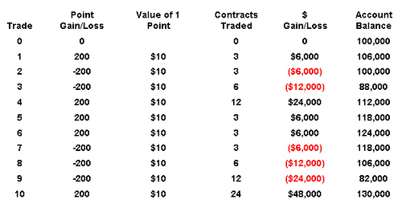
As you can see from the above example although the trader was down significantly going into the 10th trade, as the 10th trade was profitable he made up all his losses plus brought the account profitable by the equity high of the account, plus original profit target of $6000.
At first glance the above method can seem very sound and people often point to their perception that the chances of having a winning trade increase after a string of losing trades. Mathematically however the large majority of strategies work like flipping a coin, in that the chances of having a profitable trade on the next trade is completely independent of how many profitable or unprofitable trades one has leading up to that trade. As when flipping a coin no matter how many times you flip heads the chances of flipping tails on the next flip of the coin are still 50/50.
The second problem with this method is that it requires an unlimited amount of money to ensure success. Looking at our trade example again but replacing the last trade with another losing trade instead of a winner, you can see that the trader is now in a position where, at the normal $1000 per contract margin level required, he does not have enough money in his account to put up the necessary margin which is required to initiate the next 48 contract position.
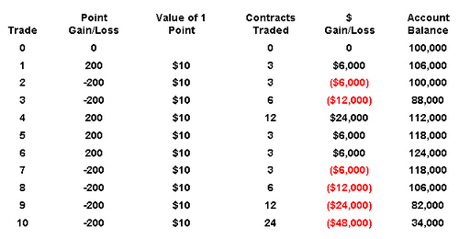
So while the pure martingale strategy and variations of it can produce successful results for extended periods of time, as I hope the above shows, odds are that it will eventually end up in blowing ones account completely.
With this in mind the large majority of successful traders that I have seen follow anti martingale strategies which increase size when trades are profitable, never when unprofitable, and these are the methods which I will be covering starting in tomorrow’s lesson.

Lesson 4: PCT Risk Sizing Method
In yesterday’s lesson we talked about the martingale and anti martingale methods of trading which are the two categories which position sizing methodologies fall into. In today’s lesson we are going to talk about one of the most basic anti martingale strategies, which is discussed in Dr. Van K. Tharp’s book Trade Your Way to Financial Freedom, the Percent Risk Model.
The first step in determining your position size using this method is to decide how much you are going to risk on each trade in terms of a percentage of your trading capital. As we have discussed in our previous lessons on setting stop losses, studies have proven that over the long term traders who risk more than 2% of their capital on any one trade normally are not successful over the long term. Another factor to consider here when setting this percentage are things such as the win rate (how many winning trades) your stock, futures, or forex trading strategy is expected to have versus the number of losing trades as well as other components which we will discuss in future lessons.
Once this loss in percentage terms has been determined, setting your stop then becomes a function of knowing how large a position can be traded while still being below your maximum risk level.
As an example lets say you have $100,000 in trading capital and you have determined from analyzing your strategy that 2% or $2000 (2%*$100,000) of your trading capital is an appropriate amount to risk per trade. When analyzing the Crude Oil Futures market you spot an opportunity to sell crude at $90 a barrel at which point you feel there is a good chance it will trade down to at least $88 a barrel. You have also spotted a strong resistance point at just below $91 a barrel and feel that 91 is a good level to place your stop and also gives you a reward to risk ratio of 2 to 1.
From trading crude oil you know that a 1 cent or 1 point move in the market equals $10 per contract. So analyzing further to determine your position size you would multiply $10 times the number of points your stop is away from your entry price (in this case 100) and you would come up with $1000 in risk per contract. Lastly you divide the total dollar amount you are willing to risk by your total risk per contract ($2000 total risk/$1000 risk per contract) to get the number of contracts which you can place on this trade (in this case 2 contracts)
As Dr. Van K. Tharp Points out in his book Trade Your Way to Financial Freedom, the advantages of this style of position sizing are that it allows both large and small accounts to grow steadily and that it equalizes the performance in the portfolio by the actual risk. As he also points out the disadvantages of this system are that it will require you to reject some trades because they are too risky (ie you will not have enough money in your account to trade the minimum contract size while staying under your maximum risk level) and that there is no way to know for sure what the actual amount you are risking will be because of slippage which can result in dramatic differences in performance when trading larger positions or using tight stops.
That completes our lesson for today. In tomorrow’s lesson we will look at another position sizing model which is known as the Percent Volatility Model.

Lesson 5: PCT Volatility Position Sizing Method
In our last lesson we furthered our discussion on the importance of position sizing in successful trading and talked about the % Risk Model which many traders use to determine their position sizes. In today’s lesson we are going to talk about another method which Dr. Van K Tharp talks about in his book Trade Your Way to Financial Freedom, the % Volatility Model for position sizing.
As we have discussed in our previous lesson on the Average True Range, Volatility is basically how much the price of a financial instrument fluctuates over a given time period. Just as the Average True Range, the indicator that was designed to represent average volatility in an instrument over a specified time, can be referenced when determining where to place your stop, it can also be used to determine how large or small a position you should trade in a given financial instrument.
To help understand how this works lets take another look at the example we used in our last lesson on the % Risk Model for position sizing, but this time determine our position size using the % Volatility Model for position sizing.
The first step in determining what your position size will be using the % Volatility Model is specifying what % of your total trading equity you will allow the volatility as represented by the ATR to represent. For this example we will say that we will allow Daily Volatility as represented by the ATR to account for a maximum of a 2% loss of trading capital.
If you remember from the example used in our last lesson we had $100,000 in trading capital and we are looking to sell crude oil which in that example was trading at $90 a barrel. After pulling up a chart of crude oil and adding the ATR you see that the current ATR for Crude is $2.55. As you may also remember from our last lesson a 1 point or 1 cent move in Crude equals $10 per contract. So with this in mind that volatility in dollars per contract for crude equals $10X255 which is $2550.
So as 2% of our trading capital that we are willing to risk on a volatility basis equals $2000 under this model we cannot put a position on in this instance and would have to pass up the trade.
As Dr. Van Tharp states in his book, the advantage of this model is that it standardizes the performance of a portfolio by volatility or in other words does not allow financial instruments with a higher volatility to have a greater affect on performance than financial instruments with a lower volatility and vice versa.
The position sizing methodology that one ultimately chooses for his strategy should be decided by testing the strategy, the methodology for which we will cover in later lessons, and seeing which method works best with that particular strategy.
That’s our lesson for today and while there are many other methods of position sizing out there which I encourage you to explore, this finishes up my series on the subject.

