Lesson 1: The Solution to Why Traders Lose Money
Over the last several years working in financial services I have watched hundreds if not thousands of traders trade, and over and over again I see smart people who have been intelligent enough to accumulate large sums of money in their non trading careers open a trading account and loose huge sums of money making what you would think are easily avoidable mistakes that one would think even the dumbest traders would avoid.
Those same traders are the ones that consider themselves too good or smart to make the same mistakes that so many others make, and that will skip over this section to get to what they feel is the “real meat” of trading, strategies for picking entry points. What these traders and so many others fail to realize is that what separates the winners from the losers in trading is not how good someone is at picking their entry points, but how well they factor in what they are going to do after they are in a trade into their trade entries and how well they stick to their trade management plan once they are in the trade.
For the few who do get that money management is far and away the most important aspect of trading, the large majority of these people don’t understand the large role that trading psychology plays in money management or consider themselves above having to work on channeling their emotions correctly when trading.
So in this series of lessons we are going to first start with a look at the psychology of money management and the role that this plays in causing so many traders to loose their shirts and then move on to ways of managing this before finishing up with specific strategies for managing trades once you are in them.
While not the most exciting part of trading, I assure you that if you don’t understand and work on the concepts presented in this section you are pretty much doomed to failure as a trader no matter how well you understand the other aspects of trading. Having said this I also assure you that if you do understand and work to expand your knowledge of the concepts presented in this series you will be well on your way to becoming a successful trader.

Lesson 2: Why Traders Hold Losing Positions
In our last lesson we introduced the concept that money management in trading and the psychology of money management as the most overlooked but most important component of trading success. In today’s lesson we will begin to look at one of the most important components of the psychology of money management: a willingness to be wrong.
Humans in general grow up being taught by their environment of the importance of always being right. Those who are right are envied as the winners in society and those who are wrong are cast aside as losers. A fear of being wrong and the need to always be right will hold you back in general, but will be deadly in your trading.
How Most People Associate Profitable Trades:
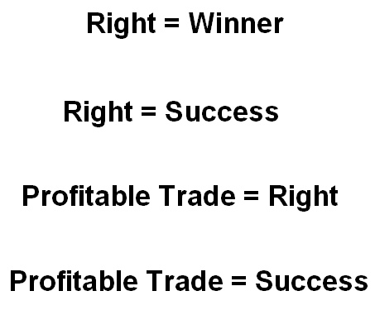
How Most People Associate Unprofitable Trades:
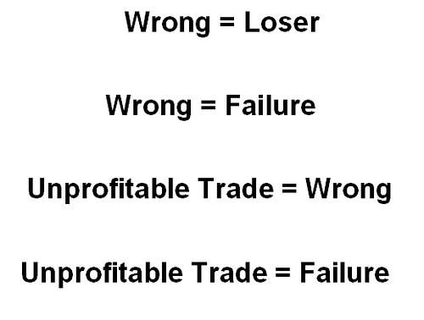
With this in mind lets say that you have been watching my trading video lessons and feel that I am an intelligent trader, so you want me to give you a forex trading strategy. I say fine and give you a method and tell you that the method will trade 100 times a year with an average profit of 100 points for winning trades and an average loss of 20 points for loosing trades. You say great and take the trading strategy home to give it a try.
A few days later the first trade comes and quickly hits its profit target of 80 points. Great you say and call a bunch of your friends to tell them about the great system you’ve found. Then a few days later the next trade comes but quickly takes a loss. You hold tight however and then the next trade comes, and the next trade etc until the trade has hit 5 losers in a row and amounting to 100 points in loses on the losers so you are now down 20 points overall, and all your trader buddy’s who started following the system after the first trade are now down 100 points.
Now you feel really dumb and are the joke among the group of guys that you trade with, so the next day you come back to me yelling about how bad the system I gave you is. I say ok and tell you I have another system for you. This one also trades 100 times a year but has a higher success rate that I think he will be happy with. You take this system home and the next day it quickly hits a winner followed by another then another and then another until over the next few days you have 5 winners in a row totaling 50 points in gains for your account. Getting very excited you call all of your trader friends and tell them that this time you have found it, you tell your wife how you haven’t lost on a trade in two weeks and you rub your perfect trading statement in the face of all your trader buds as revenge.
So now ask yourself this question. If you were really the trader in this example which system would you rather have?
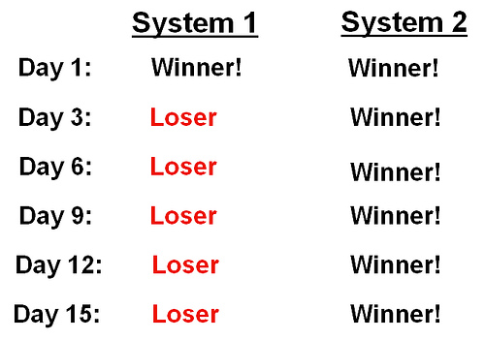
I can tell you from experience that the large majority of traders will take the second system without a second thought, and on top of that will stick with it even if it hits a few losses that wipe out most or all of its gains.
Although the successful trader will want to know a lot more about both these systems which we are going to learn about in the lessons that come before deciding which one to trade I can tell you that what they will glean from the above information is the following:
Not including transaction costs such as commissions and slippage, for the first system I only need to be right 1 time for every 5 times that I am wrong in order to break even. With this in mind seeing the system trade for one profit and 5 losses is not giving the system a chance to prove itself. It would not be out of the ordinary for a system such as this to hit even 10 losers in a row and still end up profitable for the year.
As I did not give the trader success rates for the second system there is no way to know for sure but the first suspicions that the successful trader is going to have of the second system is that it is simply a system which sets tight profit targets and very wide or no stops at all. What this means is that the system is going to take a lot of small winners and a very few large losses which have the potential to wipe out all the gains in the account and possibly a lot more.
Most of the successful systems that I have seen fall into the category of the first one we looked at in that they take a lot of small losses and make their gains for the year on a few big winners. As in this example however most traders do not have the mental toughness to stay with these types of systems during the long loosing streaks and give up on them prematurely, and throwing a profitable methodology in the trash without giving it a chance.
This concludes this lesson. You should now have a good understanding of the affect that losses have on ones decisions in trading and can begin to prepare yourself for the losses which are going to inevitably come with any trading methodology whether good or bad. In tomorrow’s lesson we are going to look at two common trading mistakes that often knock traders out of the market.

Lesson 3: Two Mistakes That Will Destroy Your Trading Account
In our last lesson we looked at how social influences can warp a trader’s view on what success and failure actually are when it comes to their trading psychology and ability to accept losses. In today’s lesson we are going to look at some of the most common mistakes that even the smartest people make when entering into trading as a result of humans ingrained need to be right.
One of the most common mistakes is sticking in a trade where you know your forex trading strategy is correct, but the market continues to move against you. As the famous economist John Maynard Keynes once said:
“The markets can remain irrational longer than you can remain solvent”
Perhaps one of the best examples of this are those who shorted the NASDAQ into the run up in 1999 and early 2000. At the time it was pretty obvious that from a value standpoint NASDAQ stocks were way overvalued and that people’s expectations for growth that they were buying on were way out of line with reality. There were many great traders at the time who recognized this and began shorting the NASDAQ starting in late 99. As you can see from the below chart and the huge sell off that ensued after the peak in 2000, these traders were right in their analysis. Unfortunately for many of them however stocks continued to run up dramatically from already overvalued points in late 99 wiping out many of these traders who would eventually be proved correct.
So as we learned about in last lesson, people’s strong desire to be right will often times keep them in trades that they should have moved on from even though the market may eventually prove them correct.
For those traders who are able to initially move on from trades where they feel they are correct but the market moves against them, another common theme which arises is for a trader to initially stick to his forex trading strategy, but after being proved correct and missing out on gains he becomes frustrated and deviates from his plan so that he will not miss out on another profitable opportunity.
One place of many where I have seen this time and time again is when watching traders who trade reversals at support or resistance levels. Many times when the market touches a support or resistance level it will have a brief spike upwards or downwards which hits the stops of a trader looking to profit from the reversal, taking him out of the market just as it turns in his favor. Because many traders think a like, often times the level at which the trader is taken out of the market is right at his stop level as well.
After this happens once or twice to a trader he will then stop placing hard stops in the market and instead convince himself that he will manage the trade if it moves against him. This may work a few times for the trader giving him more confidence in the trading strategy until the market does finally break. As we have learned about in previous lessons often times when the market breaks significant support or resistance levels it will break violently to the point where the trader in the above situation is quickly down a large amount on his trade. Typically what will happen at this point is instead of taking the big loss, learning his lesson, and moving on the trader will remain in the position or worse add to it with the hopes that the market will turn back in his favor. If the trader gets lucky and the market does turn back in his favor this only goes to support this bad habit which will eventually knock him out of the market.
Successful traders realize that situations such as the above occur constantly in the market and that one of the main things that separates successful traders from unsuccessful ones is their ability to accept this, stick to their strategy, accept that loosing trades are a part of trading, and move onto the next trade when the market does not move in their favor.
That’s our lesson for today. In our next lesson we are going to look at another major part of trading psychology which is related to not wanting to take losses which is people’s desire to follow the crowd.

Lesson 4: Crowd Psychology: Following the Sheep to Slaughter
In our last lesson we looked at two of the most common mistakes that traders make when entering the market, sticking with a trade where the market moves against the trader but he knows he is right, and altering a trading plan on the fly as a result of missed opportunities. In today’s lesson we are going to look at another aspect of trading psychology that causes many traders to fail which is known as crowd psychology.
The best summary that I have seen on this subject, as well as a great book on trading in general is Dr. Alexander Elder’s book Trading for a living. As the Trader and Psychologist points out in his book, people think differently when acting as part of a crowd than they do when acting alone. Dr Elder points out that
“People change when they join crowds. They become more credulous, impulsive, anxiously search for a leader, and react to emotions instead of using their intellect.”
In his book Dr. Elder gives several examples of academic studies which have been done which show that people have trouble doing simple tasks such as choosing which line is longer than the other when put in a situation with other people who were instructed to give the wrong answer.
Perhaps no where is the strange effect is the psychology of crowds seen than in the financial markets. One of the more recent examples as I have spoken about in my other lessons of the effect that the psychology of crowds can have on the markets is the run-up of the NASDAQ into 2000. As you will find by pulling out the history books however, this is not an isolated incident as financial history is littered with similar price bubbles created and then destroyed in the same way as the NASDAQ bubble was.
So why does history continue to repeat itself? As Dr. Elder points out in his book, from a primitive standpoint chances of survival are often much higher as part of a group than they are alone. Similarly war’s are often one by militaries with the strongest leaders. It is thus only natural to think that humans desire to survive would breed a desire to be part of a group with a strong leader into the human psyche.
So how does this relate to trading? Well as we learned in our lessons on Dow Theory, the price is representative of the crowd and the trend is representative of the leader of that crowd. With this in mind think about how difficult it would have been to short the NASDAQ at the high’s in 2000, just at the height of the frenzy when everyone else was buying. In hindsight you would have ended up with a very profitable trade but, had the trade not worked out, people would have asked how could you have been so dumb to sell when everyone else knew the market was going up?
Now think about all the people who held on to their positions and lost tons of money after the bubble burst in 2000. As they had lots of company there were probably not a whole lot of people who were laughing at them. Yes they were wrong but how could they have known when so many others were wrong too?
By looking at this same example, you can also see how panic selling often ensues after sharp trends in the market as this is representative to a crowd whose leader has abandoned them.
In order to trade successfully people need a trading plan which is designed before entering a trade and becoming part of the crowd so they can fall back on their plan when the emotions which are associated with being part of a crowd inevitably arise. Successful traders must also realize that there is a time to run with the crowd and a time to leave the crowd, a decision which must be made by a well thought out trading plan designed before entering a trade.
That completes our lesson for today and our lessons on the trading psychology of money management.

