Lesson 1: An Introduction to Candlesticks
In our last lesson we finished up our series on technical indicators with a look at the Parabolic SAR. In today's lesson we are going to start a new series on Candlestick chart formations by looking at some of the most common candlestick patterns in the market.
As you should remember from our lesson on the basics of trading charts, candlestick charts display the open, high, low, and close of an instrument and shade the "candle" portion white if the close of the period is greater than the open of the period, and black if the close for the period is less than the open. The high and the low of the period are then connected by a thin line which is referred to as the wick.
Example:
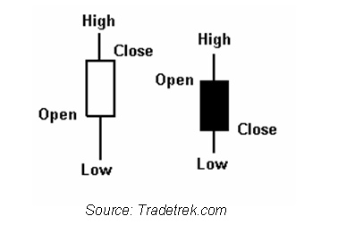
At their most basic candlestick charts give us a picture of how volatile a particular period was and whether buyers or sellers won the trading period the candlestick represents. If a candle is long and white, this tells us that the period started with buyers in control and remained that way as they drove prices higher throughout the period. If a candle is long and black this is an indication of a volatile period where sellers won out over buyers. The less of a wick there is on a long candle the greater the control of either the buyers or the sellers depending on the color of the candle.
Example
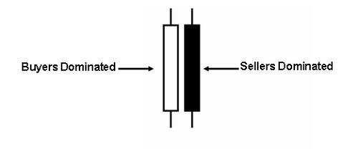
Candlesticks which have long wicks and short bodies indicate periods where there was a lot of action pushing the market either higher or lower but where it ended up closing right near the open.
If there is a long part of the wick on the upper part of the candle means that buyers initially ran the market up against the sellers but then the sellers pushed the market back against the buyers to close the period right where it opened. Conversely if the long part of the wick is below the candle this means that sellers initially pushed the market against the buyers but buyers then pushed back successfully against the sellers to close the period near its opening.
Example
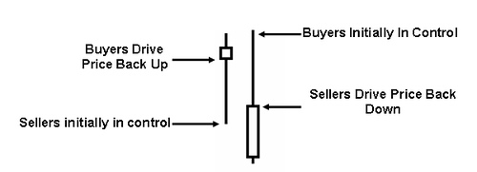
Short candlesticks represent periods in the market where the market closed near its open for the period and can represent either periods of little market activity or periods of activity where neither buyers nor sellers gained much ground.
Example
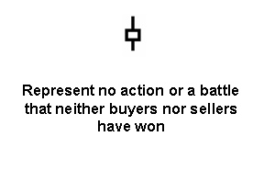
That concludes our lesson on the basics of candlesticks. In our next lesson we are going to look at two candlestick patterns called The Doji and The Spinning Top and what they can tell us about the supply demand situation in the market so we hope to see you in that lesson.

Lesson 2: The Spinning Top and Doji
In our last lesson we learned how different candlestick formations can tell us different things about whether the buyers or the sellers won out in a particular time period. In today’s lesson we are going to look at some of the basic candlestick patterns and what they mean when looked at in the context of recent price action in the market.
The Spinning Top
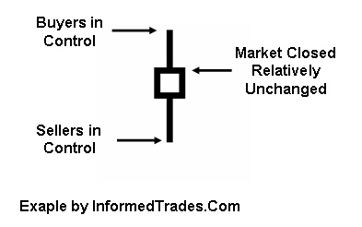
When a candlestick with a short body in the middle of two long wicks forms in the market this is indicative of a situation where neither the buyers nor the sellers have won for that time period as the market has closed relatively unchanged from where it opened. The upper and lower long wicks however tell us that both the buyers and the sellers had the upper hand at some point during the time period the candle represents.
When you see this type of candlestick form after a runup or run down in the market it can be an indication of a pending reversal as the indescision in the market is representative of the buyers loosing momentum when this occurs after an uptrend and the sellers loosing momentum after a downtrend.
Spinning top After a Trend
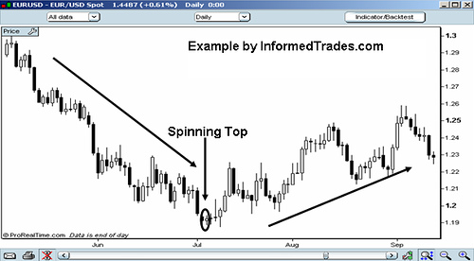
The Doji
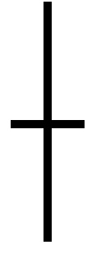
Like the Spinning Top the Doji Represents indecision in the market but is normally considered a stronger signal because unlike the spinning top the open and the close that form the Doji Candle are at the same level. If a Doji forms in sideways market action this is not significant as the sideways market action is already indicative of indecision in the market.
If the Doji forms in an uptrend or downtrend this is normally seen as significant as this is a signal that the buyers are loosing conviction when formed in an uptrend and a signal that sellers are loosing conviction if seen in a downtrend. Most traders will place greater significance on the Doji when it forms in a market that is in overbought or oversold territory.
Doji After a Trend
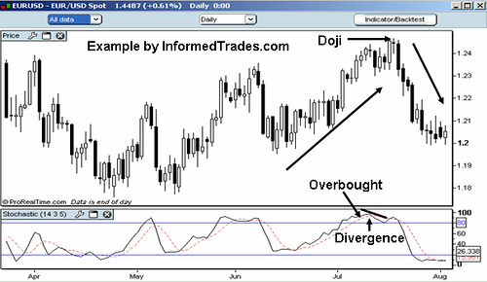
That completes our lesson for today. In our next lesson we are going to look at several more candlestick formations known as the Bullish and Bearish Engulfing Candlestick Patterns and how traders use these in their trading strategies so we hope to see you in that lesson.
Lesson 3: Bullish and Bearish Engulfing Formations
In our last lesson we looked at two candlestick patterns which represent an indecisive moment in the market and can also represent a potential trend reversal when seen during an uptrend or downtrend in the market and are known as the spinning top and doji candlestick patterns. In today’s lesson we are going to look at two more candlestick patterns which also can represent potential reversals which are known as the Bullish and Bearish Engulfing Patterns.
The Bullish Engulfing Pattern
The Bullish Engulfing pattern is another candlestick formation which represents a potential reversal in the market when seen in a downtrend. The pattern is made up of a white and black candle where the latest candle (the white candle) opens lower than the previous candle’s (the black candle) close and closes higher than the previous candle’s open. When this happens the current period’s white candle completely engulfs the body previous period’s black candle.
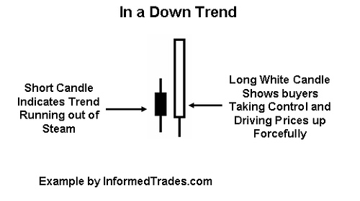
Unlike the Spinning Top and the Doji we learned about in the last lesson, the Bullish Engulfing Pattern represents not indecision in the market, but a situation where the control has shifted from sellers to buyers. The long body of the current candle completely engulfing the body of the previous candle to the upside is representative that the buyers have not only taken control, but have taken control with force. As such, when this pattern is seen during a downtrend in the market it is seen as a potential sign that the trend may be reversing.

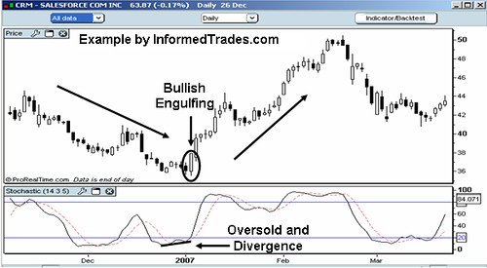
There are several instances where traders will normally see greater potential for a reversal which are:
- The longer the white candle and the smaller the black candle which precedes it the greater the potential for reversal
- When the white candle completely engulfs the black candle that precedes it
- When there is large volume during the period in which the white candle forms
The Bearish Engulfing Pattern
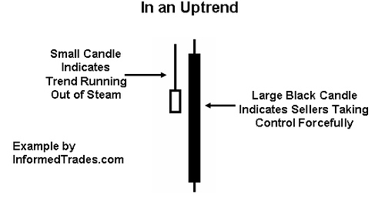
The Bearish Engulfing Pattern is a Mirror Image of the Bullish Engulfing Pattern so the same rules apply, just in reverse. The Bearish Engulfing pattern when seen in an uptrend is representative of a potential reversal of that trend. The pattern is made up of a white and black candle where the latest candle (the black candle) opens higher than the previous candle’s (the white candle) close and closes lower than the previous candle’s open. When this happens the current period’s black candle completely engulfs the body of the previous period’s white candle.
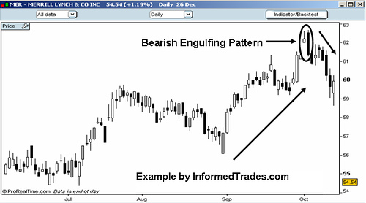
There are several instances where traders will normally see greater potential for a reversal which are:
- The longer the black candle and the smaller the white candle which precedes it the greater the potential for reversal
- When the black candle completely engulfs the white candle that precedes it
- When there is large volume during the period in which the white candle forms
That completes our lesson for today. In tomorrow’s lesson we are going to learn about two more candlestick patterns which are also potential reversal patterns known as the hammer and the hanging man candlestick patterns so we hope to see you in that lesson.

Lesson 4: Hammer and Hanging Formations
In our last lesson we learned about the Bullish and Bearish Engulfing Candlestick Patterns which can represent reversal patterns when found in an uptrend or a downtrend. In Today’s lesson we are going to look at two more candlestick Patterns which are known as the Hammer and the Hanging man.
The Hammer
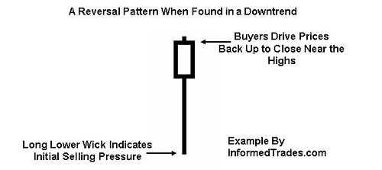
Like the Spinning Top and Doji which we have studied in previous lessons where we learn to trade chart patterns, the Hammer candlestick pattern is made up of one candle. The candle looks like a hammer as it has a long lower wick and a short body at the top of the candlestick with little or no upper wick. In order for a candle to be a valid hammer most traders say the lower wick must be two times greater than the size of the body potion of the candle, and the body of the candle must be at the upper end of the trading range.
When you see the Hammer form in a downtrend this is a sign of a potential reversal in the market as the long lower wick represents a period of trading where the sellers were initially in control but the buyers were able to reverse that control and drive prices back up to close near the high for the day, thus the short body at the top of the candle.
After seeing this chart pattern form in the market most traders will wait for the next period to open higher than the close of the previous period to confirm that the buyers are actually in control.
Two additional things that traders will look for to place more significance on the pattern are a long lower wick and an increase in volume for the time period that formed the hammer.
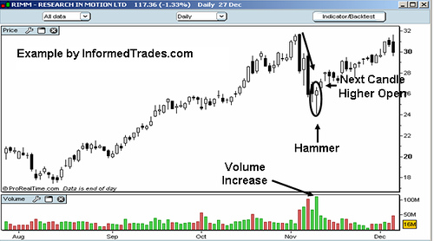
The Hanging Man
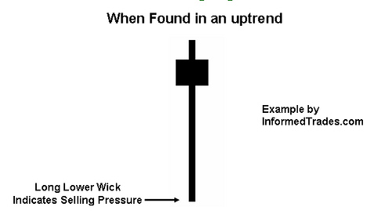
The Hanging Man is basically the same thing as Hammer formation but instead of being found in a downtrend it is found in an uptrend. Like the Hammer pattern, the Hanging man has a small body near the top of the trading range, little or no upper wick, and a lower wick that is at least two times as big as the body of the candle.
Unlike the Hammer however the selling pressure that forms the lower wick in the Hanging Man is seen as a potential sign of more selling pressure to come, even though the candle closed in the upper end of its range. While the lower wick of the Hammer represents selling pressure as well, this is to be expected in a downtrend. When seen in an uptrend however selling pressure is a warning sign of potential more selling pressure to come and thus the categorization of the Hanging Man as a bearish reversal pattern.
As with the Hammer and as with most one candle chart patterns most traders will wait for confirmation that selling pressure has in fact taken hold by watching for a lower open on the next candle. Traders will also place additional significance on the pattern when there is an increase in volume during the period the Hanging Man forms as well as when there is a longer wick.
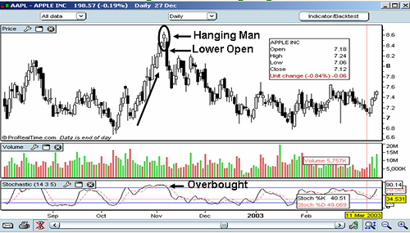
That completes our lesson for today. In our next lesson we will look at two additional reversal patterns which are known as the Morning and Evening Star Candlestick Patterns so we hope to see you in that lesson.

Lesson 5: Morning and Evening Star Formations
Lesson 5: Morning and Evening Star Formations
In our last lesson we looked at the Hammer and Hanging Man Candlestick Chart Patterns. In today’s lesson we are going to look at two more reversal candlestick patterns which are known as the Morning and Evening Star.
The Morning Star
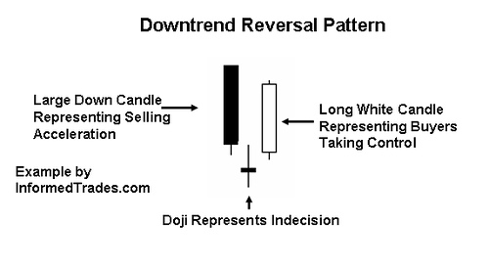
The Morning Star Candlestick Pattern is made up of 3 candles normally a long black candle, followed by a short white or black candle, which is then followed by a long white candle. In order to have a valid Morning Start formation most traders will look for a close of the third candle that is at least half way up the body of the first candle in the pattern. When found in a downtrend, this pattern can be a powerful reversal pattern.
What this represents from a supply demand situation is a lot of selling into the downtrend in the period which forms the first black candle, then a period of lower trading but with a reduced range which forms the second period and then a period of trading indicating that indecision in the market, which is then followed by a large up candle representing buyers taking control of the market.
Unlike the Hammer and Hanging Man which we learned about in our last lesson, as the Morning Star is a 3 candle pattern traders often times will not wait for confirmation from the 4th candle before entering the trade. Like those patterns however traders will look to volume on the third day for confirmation. In addition traders will look to the size of the size of the candles for indication on how big the reversal potential is. The larger the white and black candle and the further that the white candle moves up into the black candle the larger the reversal potential.
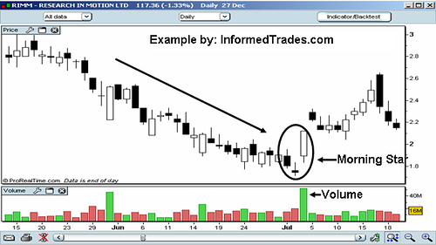
The Evening Star
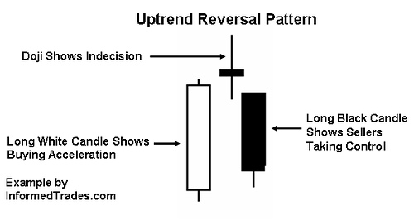
The Evening Star Candlestick Pattern is a mirror image of the Morning Star, and is a reversal pattern when seen as part of an uptrend. The pattern is made up of three candles the first being a long white candle representing buyers driving the prices up, then a short white or black second candle representing indecision in the market, which is followed by a third black candle down which represents sellers taking control of the market.
The close of the third candle needs to be at least half way down the body of the first candle and as with the Morning Star most traders will not wait for confirmation from the 4th period’s candle to consider the pattern valid. Traders will look for increased volume on the third period’s candle for confirmation, the larger the black and white candles are and the further the black candle moves down the body of the white candle the more powerful the reversal is expected to be.
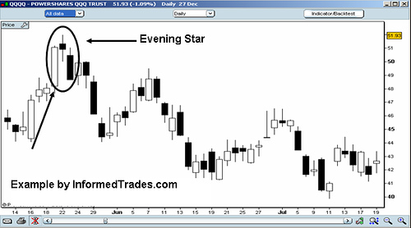
That’s our lesson for today. In our next lesson we are going to finish up our series on Candlestick patterns with a look at the Shooting Star and Inverted Hammer Candlestick Patterns.

Lesson 6: Inverted Hammer and Shooting Star Formations
In our last lesson we learned about the Morning and Evening Star Candlestick Patterns. In today's lesson we are going to wrap up our series on candlestick chart patterns with a look at the Inverted Hammer and the Shooting Star candlestick patterns.
The Inverted Hammer Candlestick Pattern
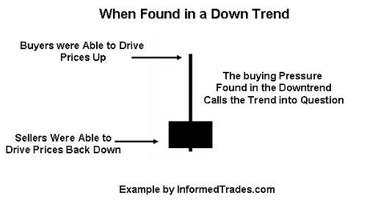
As its name implies, the inverted Hammer looks like an upside down version of the Hammer Candlestick Chart Pattern which we learned about several lessons ago. Like the Hammer Pattern, the Inverted Hammer is comprised of one candle and when found in a downtrend is considered a potential reversal pattern.
The pattern is made up of a candle with a small lower body and a long upper wick which is at least two times as large as the short lower body. The body of the candle should be at the low end of the trading range and there should be little or no lower wick in the candle.
What this chart pattern is basically telling us is that although sellers ended up driving price down to close near to where it opened, buyers had significant control of the market at some point during the period which formed the long upper wick. This buying pressure during the downtrend calls the trend into question which is why the candle is considered a potential reversal pattern. Like the other one candle patterns we have learned about however, most traders will wait for a higher open on the next trading period before taking any action based on the pattern.
Most traders will also look at a longer wick as a sign of a greater potential reversal and like to see an increase in volume on the day the Inverted Hammer Forms.
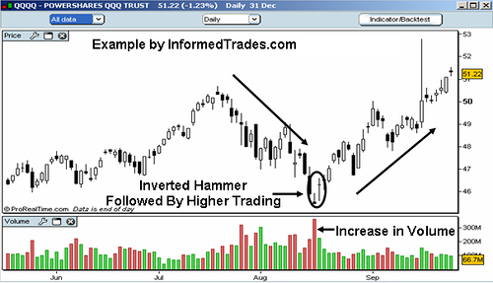
The Shooting Star Candlestick Pattern
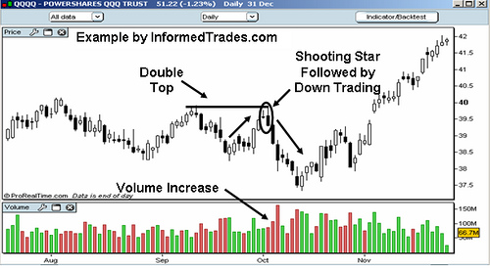
The Shooting Star looks exactly the same as the Inverted Hammer, but instead of being found in a downtrend it is found in an uptrend and thus has different implications. Like the Inverted Hammer it is made up of a candle with a small lower body, little or no lower wick, and a long upper wick that is at least two times the size of the lower body.
The long upper wick of the chart pattern indicates that the buyers drove prices up at some point during the period in which the candle was formed but encountered selling pressure which drove prices back down for the period to close near to where they opened. As this occurred in an uptrend the selling pressure is seen as a potential reversal sign. When encountering this pattern traders will look for a lower open on the next period before considering the pattern valid and potentially including it in their trading strategy.
As with the Inverted Hammer most traders will see a longer wick as a sign of a greater potential reversal and like to see an increase in volume on the day the Shooting Star forms.
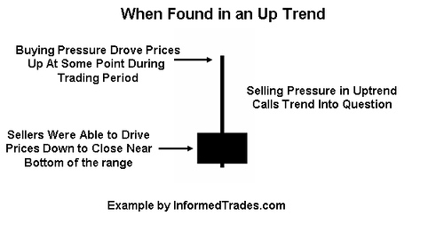
That completes this lesson and wraps up our series on candlestick chart patterns. In our next lesson we are going to start a new series with a look at Money Management and how this applies to profitable trading so we hope to see you in that lesson.

