Lesson 1: An Introduction to Technical Indicators
In our last lesson we finished up our series on chart patterns with a look at strategies which can be used to trade triangle chart patterns. In this lesson we are going to start a new series on technical indicators with an overview of what technical indicators are, and how traders use them to help pick their entry and exit points.
A technical indicator is a mathematical formula which is derived from the price action of a financial instrument and/or the volume traded. The results of these formulas are commonly displayed in graphical form above or below a financial instruments price chart, and are used to help predict future price movement. When used in combination with other forms of technical analysis, such as the chart patterns we have learned so far, technical indicators can be a powerful compliment which traders can use to assist in their trading decisions.
Technical indicators can be broken down into two main categories which are leading and lagging indicators. As their name suggests, leading indicators are created to try and predict future price movement. Because most leading indicators are trying to gauge price momentum from relatively recent price action, these indicators tend to generate frequent buy and sell signals and are therefore normally used in ranging markets. While some traders like the opportunity to enter more trades, it is important to keep in mind that the potential for false signals with leading indicators is high.
Lagging indicators on the other hand are created to give a picture of where the market has been, and therefore where it is likely to continue to go. As this is the case these indicators are normally used by traders looking to trade with the trend, and offer little value in ranging markets. Secondly because these indicators are designed to catch and stay with the trend for as long as possible, they generate less trading signals than leading indicators. This is often seen as a positive from the standpoint of generating less false trading signals and also a negative as this also means that they normally get you into a move later than a leading indicator.
One of the biggest issues when deciding how and when to use a particular indicator is determining how sensitive to make the indicator to price movements. The more sensitive the indicator the earlier you will catch the move, however the more false signals that will be given. Conversely the less sensitive the indicator the less false signals but the later you will get into the move.
That completes this lesson. You should now have a good understanding of what a technical indicator is and how they are used in trading. In the lessons that come we will look at some of the more popular indicators, starting in the next lesson with moving averages, as well as how to use these indicators in your trading, so we hope to see you in those lessons.

Lesson 2: The Moving Average
In our last lesson we gave an introduction to technical indicators which started our latest series of lessons on how to use these in your trading. In this lesson we are going to start with looking at one of the most popular technical indicators, the moving average.
There are several different types of moving averages which we are going to explore here, all of which are used by traders to try and smooth out the price action of a financial instrument, and get a better feel for the longer term direction without all the noise that is often associated with just looking at price. In addition to getting a better feel for the longer term trend of a financial instrument, moving averages are also used to spot potential support and resistance levels, and are often used in conjunction with one another to generate buy and sell signals.
Before we get into the details however, let’s first have an overview of the two main types of moving averages: the simple moving average and the exponential moving average.
The Simple Moving Average:
The simple moving average is the most basic of the moving averages and is calculated by taking the past x number of points averaging them, and then plotting the resulting line on a chart. The reason it is called a moving average is because as new data points become available the average moves forward to incorporate the new data point and drops the last data point in the series.
For example, if a trader plots a 10 day moving average on a chart the last 10 days of trading are averaged to come up with the most recent point plotted on the moving average line on the chart. On the next day of trading the data point which occupied the first day used in the above moving average is dropped from the equation, the data point which was day two in the equation becomes day 1, and the next day of trading becomes the 10th data point in the equation.
Here is what a Simple Moving average Looks like on a Chart:
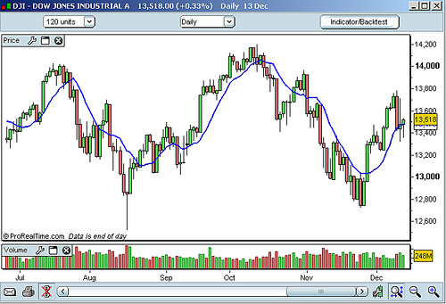
Here is an example of how it is calculated:
Data Point 1
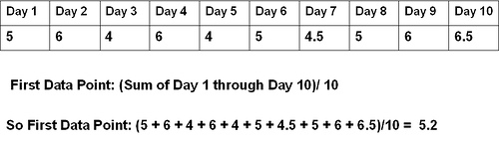
Data Point 2
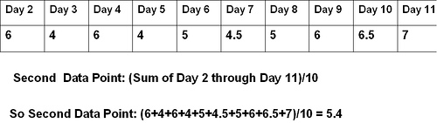
I included this example here so you can simply have a basic understanding of how the average is calculated, however any charting package which you use should automatically do the calculations for you.
The Exponential Moving Average:
Critics of the simple moving average argue that it is too simple in the sense that it gives the same weight to each point in calculating the moving average. The problem with this it is argued is that the more recent data points deserve a greater weighting in the formula as they are more relevant to the future price action of the instrument.
To solve this problem traders came up with the exponential moving average, which gives more weight to the more recent price points in calculating the moving average line. Whatever chart package that you end up using should automatically calculate the exponential moving average for you but for those who want to know the formula for doing so is below:
Exponential Moving Average Calculation:
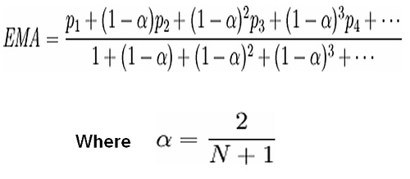
Source: Wikipidia.org
Example of an Exponential Moving Average Plotted on a Chart
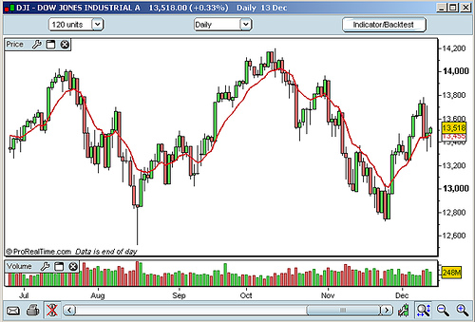
When the simple moving average and the exponential moving average are plotted together on a chart you can see that the exponential average reacts faster to the most recent price action.
Example Comparing EMA with SMA:
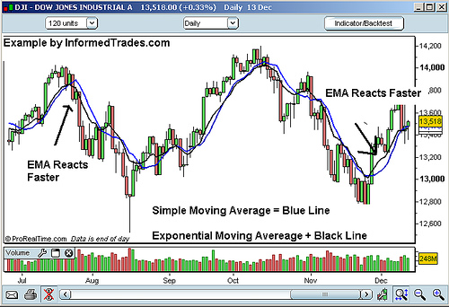
Moving averages can be created from any number of trading periods however the most commonly used are the 200 day moving average and the 50 day moving average followed by the 15, 20, and 100 day moving averages.
Whether traders use the simple or exponential moving average normally depends on trading style and the financial instrument that one is trading. As the simple moving average is slower to react than the exponential moving average traders will often use the SMA for trading longer term moves and EMA’s for shorter term moves. Lastly traders will often look at how different financial instruments have reacted in the past using both types of moving averages and then pick the one that has best represented the types of moves they are trying to trade.
This completes our lesson for today. You should now have a good understanding of moving averages and the difference between a simple and an exponential moving average. In tomorrows lesson we will look at some different ways that traders use moving averages in their trading so we hope to see you in that lesson.

Lesson 3: Trading With Moving Averages
In our last lesson we looked at the two main types of moving averages, the simple moving average and the exponential moving average. In this lesson we are going to look at some of the ways that traders use moving averages to pick their entry and exit points in the currency, commodities, and equities market.
As moving averages are lagging indicators they tend to work well in identifying and following a trend and not to work well in ranging or trend less markets. Because of this traders will often use them to trade with the trend as well as to identify potential areas of support or resistance which may result in a continuation or reversal of a trend.
The most basic way that traders will use moving averages is to identify and then trade with the trend of a particular instrument. Although most traders will probably want to use the moving average in conjunction with some of the things that we have learned so far and some of the things we will learn in future lessons, the most basic way to trade using just the moving average is to buy when the price of a financial instrument breaks above the moving average line and sell when the financial instrument breaks below the moving average line. For confirmation traders will often wait for a full bar to close above the moving average line before entering long and a full bar to close below the moving average line before entering a short position.
Example of Trend Following Using Moving Averages:
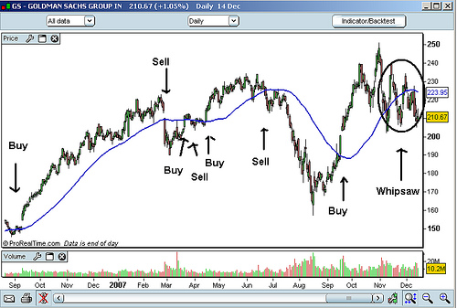
A second way that traders use moving averages is to identify areas of support or resistance and then trade the break of these levels, looking for a potential reversal of the trend. When a financial instrument has shown a particular moving average level to be significant from a support or resistance standpoint in the past by testing the moving average line several times, and then breaks that level, traders will often see this as a warning sign that the trend is reversing and position themselves accordingly.
Example of Trading Support and Resistance Breaks Using Moving Averages:
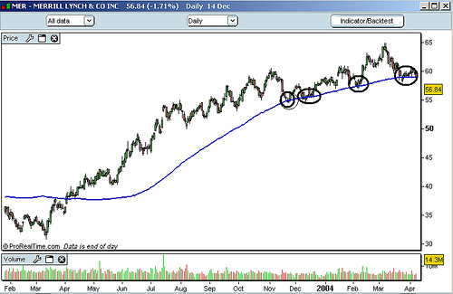
The last way that traders will using moving averages is by plotting a longer term moving average and a shorter term moving average on a chart and trading the cross over. The idea here is that the shorter term moving average will be faster in identifying changes in the trend and therefore traders will look to get long when the shorter term moving average crosses above the longer term moving average and short when the shorter term moving average crosses below the longer term moving average.
Example of Moving Average Crossovers:
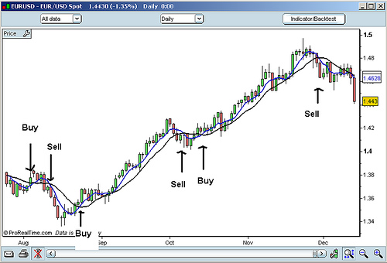
That completes this lesson. You should now have a good understanding of how many traders trade moving averages. In our next lesson we are going to look at an indicator which is based on moving averages called the Moving Average Convergence Divergence (MACD) so we hope to see you in that lesson.
Lesson 4: Moving Average Convergence Divergence (MACD)
In our last lesson we learned about the different ways people trade with moving averages. In this lesson we are going to learn about the Moving Average Convergence Divergence (MACD) an indicator that is built using moving averages, but is set up to give a good indication of the momentum of a particular financial instrument as well as its trend.
The indicator, which was developed by Gerald Appel, is constructed by taking a 12 period exponential moving average of a financial instrument and subtracting its 26 period exponential moving average. The resulting line is then plotted below the price chart and fluctuates above and below a center line which is placed at value zero. A 9 period EMA of the MACD line is normally plotted along with the MACD line and used as a signal of potential trading opportunities
Example of what a MACD looks like on a chart:
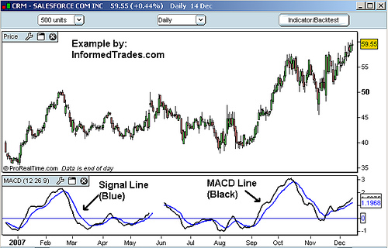
When the MACD line is above zero this tells the trader that the 12 period exponential moving average is trading above the 26 period exponential moving averages. When the MACD line is below zero this tells the trader that the 12 period exponential moving average is below the 26 period exponential moving average. Traders will watch the MACD line as when it is above zero and rising this is a sign that the positive gap between the 12 and 26 EMA’s is widening, a sign of increasing bullish momentum in the financial instrument they are analyzing. Conversely when the MACD line is below zero and falling this represents a widening in the negative gap between the 12 and 26 day EMA’s, a sign of increasing bearish momentum in the financial instrument they are analyzing.
Example of Rising and Falling MACD lines:
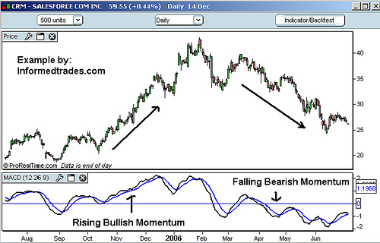
The purpose of the 9 period exponential moving average line is to further confirm bullish changes in momentum when the MACD crosses above this line and bearish changes in momentum when the MACD crosses below this line.
Example of the Signal Line
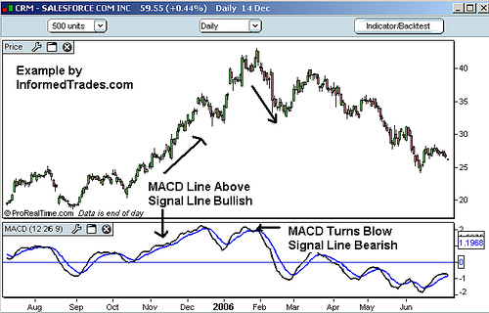
Lastly many traders and charting packages will plot a histogram along with the MACD which is representative of the distance between the MACD and its signal line. When the MACD histogram is above zero (the MACD line is above the signal line) this is an indication that positive momentum is increasing. Conversely when the MACD histogram is below zero this is an indication that negative momentum is increasing.
Example of the MACD histogram
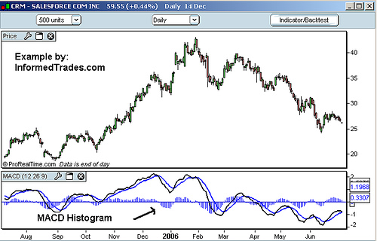
When the MACD histogram is above zero (the MACD line is above the signal line) this is an indication that positive momentum is increasing. Conversely when the MACD histogram is below zero this is an indication that negative momentum is increasing. The higher or lower the histogram goes above or below zero the greater the momentum of the trend is thought to be.
That completes this lesson. You should now have a good understanding of the different components that make up the MACD indicator. In our next lesson we are going to go over some of the different ways traders use the MACD in their trading so we hope to see you in that lesson.

Lesson 5: Trading With Moving Average Convergence Divergence (MACD)
In our last lesson we looked at the different components that make up the MACD indicator. In today’s lesson we are going to look at how traders use the MACD to identify whether or not a market is trending, how strong that trend is, and where good potential entry and exit points are.
As we learned in our last lesson the MACD indicator is used to identify trends in the market and the momentum of those trends. Because of this the MACD is an indicator that traders will look to trade when the market is trending and avoid when the market is range bound.
In addition to being able to tell if the stock, futures contract, or currency you are analyzing is trending or not from simply looking at its price action on the chart, you can also use the MACD indicator. Very simply if the MACD line is at or close to the zero line, this indicates that the financial instrument you are analyzing is not exhibiting strong trending characteristics, and thus should not be traded using the MACD.
Example of Identifying Trending and Non Trending Markets with MACD
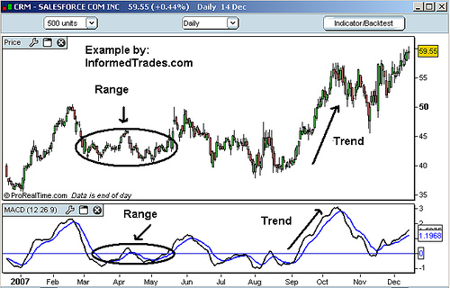
Once it is determined that the financial instrument you are analyzing is exhibiting trending characteristics, there are three ways that you can trade the MACD.
1. Positive and Negative Divergence
2. The MACD/Signal Line Crossover
3. The zero line crossover
Trading the MACD Divergence:
Divergence occurs when the direction of the MACD is not moving in the same direction of the financial instrument you are analyzing. This can be seen as an indication that the upward or downward momentum in the market is failing. Traders will thus look to trade the reversal of the trend and consider this signal particularly strong when the market is making a new high or low and the MACD is not.
Example of MACD Negative Divergence
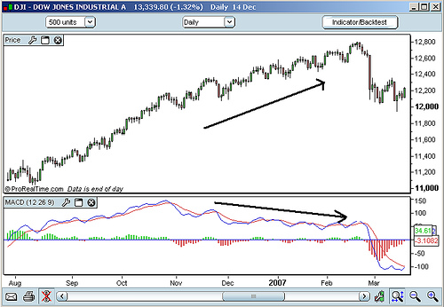
Trading the MACD Crossover
This is the simplest way to trade the MACD as it involves simply watching the MACD line and going long when the MACD line crosses above the signal line and going short when the MACD line crosses below the signal line. As this strategy generates the most signals, it also generates the most false signals, and the potential to get into a bad trade using just this method is high. For this reason traders will confirm the signals with other methods such as the chart patterns we have learned so far, volume etc.
Example of Using the MACD Crossover as Buy and Sell Signals
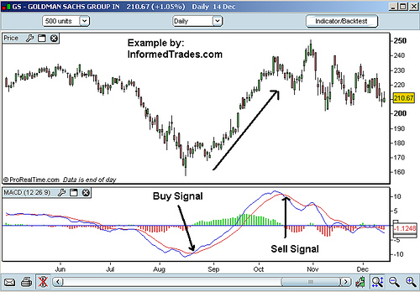
The MACD Zero Line Crossover:
The MACD zero line cross over occurs when the MACD crosses above or below the line plotted at point zero on the indicator. When this occurs it is an indication that market momentum has reversed direction. The strength of the move that can be expected as a result of this depends on what has been happening in the market, and what has been happening with the indicator. If the market and the MACD are both coming off of recent new highs then this could be considered a strong signal. If the market is simply trading in a weak trend or range and the MACD has simply crossed from just above to just below the zero line, then this would be considered a weak signal.
Example of a Bullish and Bearish Zero Line MACD Cross:
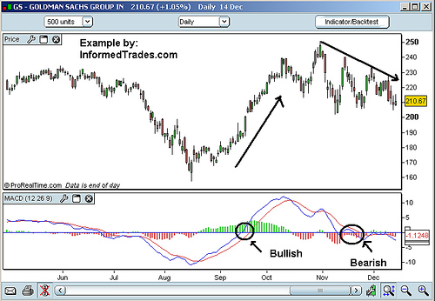
As with all of the indicators that we are learning about in this series it is normally better to trade the MACD along with other confirming signals such some of the things we have learned so far like trend lines, chart patterns, and breaks of significant support resistance levels.
That completes our lesson for today. You should now have a good understanding of the MACD and situations where it helps traders predict future price action and how it can be used to place trades. In our next lesson we are going to look at more Oscillators and look at how to trade the relative strength index (RSI).

Lesson 6: Relative Strength Index (RSI)
In our last lesson we looked at 3 different ways to trade the MACD indicator. In today’s lesson we are going to look at a class of indicators which are known as Oscillators with a look at how to trade one of the more popular Oscillators the Relative Strength Index (RSI).
An oscillator is a leading technical indicator which fluctuates above and below a center line and normally has upper and lower bands which indicate overbought and oversold conditions in the market (an exception to this would be the MACD which is an Oscillator as well). One of the most popular Oscillators outside of the MACD which we have already gone over is the Relative Strength Index (RSI) which is where we will start our discussion.
The RSI is best described as an indicator which represents the momentum in a particular financial instrument as well as when it is reaching extreme levels to the upside (referred to as overbought) or downside (referred to as oversold) and is therefore due for a reversal. The indicator accomplishes this through a formula which compares the size of recent gains for a particular financial instrument to the size of recent losses, the results of which are plotted as a line which fluctuates between 0 and 100. Bands are then placed at 70 which is considered an extreme level to the upside, and 30 which is considered an extreme level to the downside.
Example of the RSI
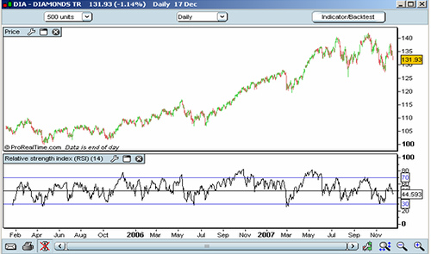
The first and most popular way that traders use the RSI is to identify and potentially trade overbought and oversold areas in the market. Because of the way the RSI is constructed a reading of 100 would indicate zero losses in the dataset that you are analyzing, and a reading of zero would indicate zero gains, both of which would be a very rare occurrence. As such James Wilder who developed the indicator chose the levels of 70 to identify overbought conditions and 30 to identify oversold conditions. When the RSI line trades above the 70 line this is seen by traders as a sign the market is becoming overextended to the upside. Conversely when the market trades below the 30 line this is seen by traders as a sign that the market is becoming over extended to the downside. As such traders will look for opportunities to go long when the RSI is below 30 and opportunities to go short when it is above 70. As with all indicators however this is best done when other parts of a trader’s analysis line up with the indicator.
Example of RSI Showing Overbought and Oversold
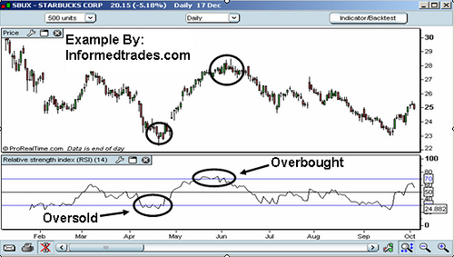
A second way that traders look to use the RSI is to look for divergences between the RSI and the financial instrument that they are analyzing, particularly when these divergences occur after overbought or oversold conditions in the market. These divergences can act as a sign that a move is loosing momentum and often occur before reversals in the market. As such traders will watch for divergences as a potential opportunity to trade a reversal in the stock, futures or forex markets or to enter in the direction of a trend on a pullback.
Example of RSI Divergence
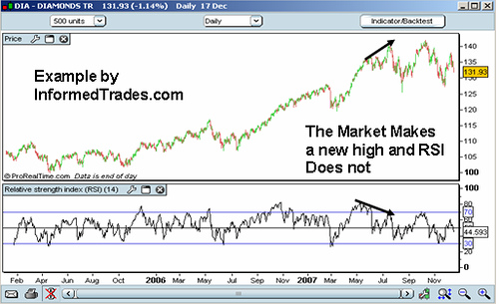
The third way that traders look to use the RSI is to identify bullish and bearish changes in the market by watching the RSI line for when it crosses above or below the center line. Although traders will not normally look to trade the crossover it can be used as confirmation for trades based on other methods. As you can see in the chart below, the RSI crossover was a great confirmation of the head and shoulders top, a pattern which we learned about in previous lessons and that occurred recently in the EUR/USD.
Example of the RSI Centerline Crossover
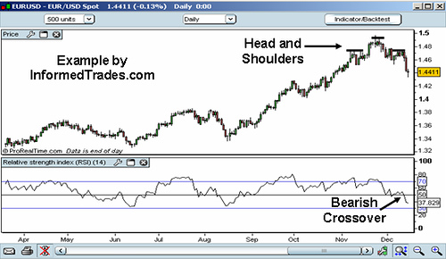
That’s our lesson for today. You should now have a good understanding of the RSI and how traders use this indicator in their trading. In tomorrows lesson we will look at another Oscillator which is known as the Stochastic Oscillator so we hope to see you in that lesson.

Lesson 7: The Stochastic Oscillator
In our last lesson we learned about the Relative Strength Index (RSI) indicator and some of the different ways traders of the stock, futures, and forex markets use this in their trading. In today’s lesson we are going to look at another momentum oscillator which is similar to the RSI and is called the Stochastic.
Let me start by saying that there are 3 different types of stochastic oscillators: the fast, slow, and full stochastic. All of them operate in a similar manner however when most traders refer to trading using the stochastic indicator they are referring to the slow stochastic which is going to be the focus of this lesson.
The basic premise of the stochastic is that prices tend to close in the upper end of their trading range when the financial instrument you are analyzing is in an uptrend and in the lower end of their trading range when the financial instrument that you are analyzing is in a downtrend. When prices close in the upper end of their range in an uptrend this is a sign that the momentum of the trend is strong and vice versa for a downtrend.
The Stochastic Oscillator contains two lines which are plotted below the price chart and are known as the %K and %D lines. Like the RSI, the Stochastic is a banded oscillator so the %K and %D lines fluctuate between zero and 100, and has lines plotted at 20 and 80 which represent the high and low ends of the range.
Example of a Stochastic Oscillator
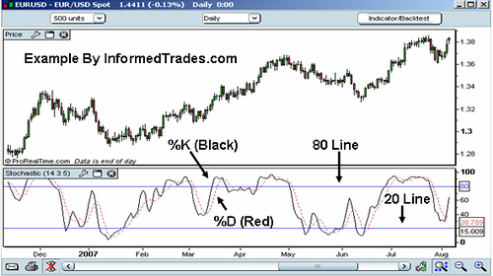
Whatever charting package you use will calculate the lines for you automatically but you should know that the data points which form the %K line are basically a representation of where the market has closed for each period in relation to the trading range for the 14 periods used in the indicator. In simple terms it is a measure of momentum in the market.
The %D line is very simply a 5 period simple moving average of the %K line. Lastly you should know that you can change the inputs for the indicator and use for example a 3 period moving average of the %K line to get faster signals, however as this is an introduction to the indicator and because most traders I know do not change the standard inputs, I do not recommend changing them at this point.
Like the RSI the first way that traders use the stochastic oscillator is to identify overbought and oversold levels in the market. When the lines that make up the indicator are above 80 this represents a market that is potentially overbought and when they are below 20 this represents a market that is potentially oversold. The developer of the indicator George Lane recommended waiting for the %K line to trade back below or above the 80 or 20 line as this gives a better signal that the momentum in the market is reversing.
Example of Overbought and Oversold Trading Signals
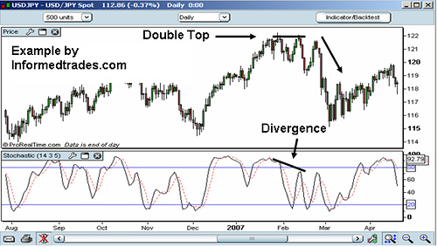
The second way that traders use this indicator to generate signals is by watching for a crossover of the %K line and the %D line. When the faster %K line crosses the slower %D line this is a sign that the market may be heading up and when the %K line crosses below the %D line this is a sign that the market may be heading down. As with the RSI however this strategy results in many false signals so most traders will use this strategy only in conjunction with others for confirmation.
Example of the Stochastic Crossover
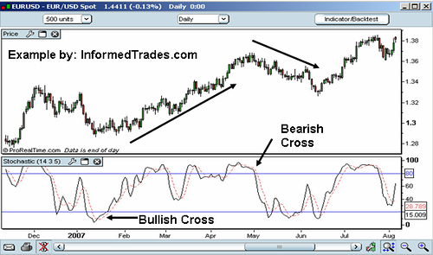
The third way that traders will use this indicator is to watch for divergences where the Stochastic trends in the opposite direction of price. As with the RSI this is an indication that the momentum in the market is waning and a reversal may be in the making. For further confirmation many traders will wait for the cross below the 80 or above the 20 line before entering a trade on divergence.
Example of Divergence
As the RSI and Stochastic are similar in nature many traders will use them in conjunction with one another to confirm signals.
That’s our lesson for today. You should now have a good understanding of the Stochastic Oscillator and some of the different ways that traders use this in their trading. In tomorrow’s lesson we are going to look at an indicator which allows us to gauge the volatility of a financial instrument over a given time called Bollinger Bands.

Lesson 8: Bollinger Bands
In our last lesson we learned about the Stochastic Oscillator and how traders use this in their trading. In today’s lesson we are going to learn about a technical indicator which helps traders gauge the volatility and how current prices compare to past prices.
Bollinger Bands are comprised of three bands which are referred to as the upper band, the lower band, and the center band. The middle band is a simple moving average which is normally set at 20 periods, and the upper band and lower band represent chart points that are two standard deviations away from that moving average.
Example of Bollinger Bands
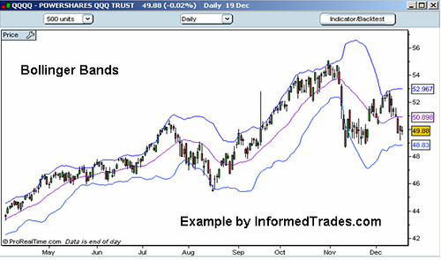
Bollinger bands are designed to give traders a feel for what the volatility is in the market and how high or low prices are relative to the recent past. The basic premise of Bollinger bands is that price should normally fall within two standard deviations (represented by the upper and lower band) of the mean which is the center line moving average. If you are unfamiliar with what a standard deviation is you can read about it here. As this is the case trend reversals often occur near the upper and lower bands. As the center line is a moving average which represents the trend in the market, it will also frequently act as support or resistance.
The first way that traders use the indicator is to identify potential overbought and oversold places in the market. Although some traders will take a close outside the upper or lower bands as buy and sell signals, John Bollinger who developed the indicator recommends that this method should only be traded with the confirmation of other indicators. Outside of the fact that most traders would recommend confirming signals with more than one method, with Bollinger bands prices which stay outside or remain close to the upper or lower band can indicate a strong trend, a situation that you do not want to be trading reversals in. For this reason selling at the upper band and buying at the lower is a technique that is best served in range bound markets.
Example of Buying and Selling at the Upper and Lower Band:
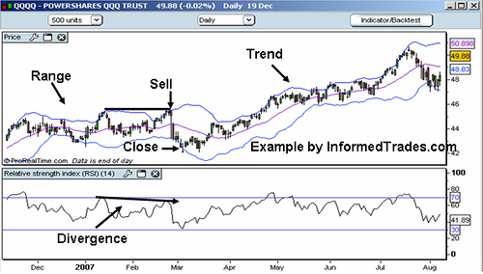
Large breakouts often occur after periods of low volatility when the bands contract. As this is the case traders will often position for a trend trade on a break of the upper or lower Bollinger band after a period of contraction or low volatility. Be careful when using this strategy as the first move is often a fake out.
Example of the Bollinger Band Contraction
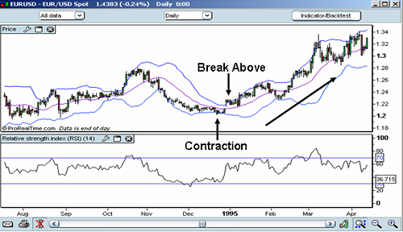
As Bollinger bands paint a good picture directly on the price chart of how high or low price is relative to historical prices, this is a good indicator to use in conjunction with other methods such as some of the chart patterns that we have learned so far and some of the candlestick patterns which we will learn in future lessons.
Bollinger Bands with Multiple Confirmation
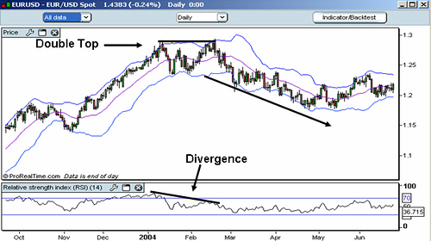
As Bollinger Bands are one of the most popular indicators around I have created a special page on InformedTrades.com which lists multiple resources for those looking for more information on trading Bollinger Bands.
That’s our lesson for today. You should now have a good understanding of Bollinger bands and how traders use these in their trading. In our next lesson we are going to go over the Average Directional Index or ADX, which helps traders identify the strength or weakness of a trend so we hope to see you in that lesson.

Lesson 9: The Average Directional Index
In our last lesson we went over Bollinger Bands, an indicator which helps traders gauge the volatility in the market as well as how high or low current prices are relative to historical prices. In this lesson we are going to learn about the Average directional Index (ADX), an indicator which helps traders determine when the market is trending, how strong or weak a trend is, and when a trend may be about to start or reverse.
Example of the Average Directional Index (ADX)
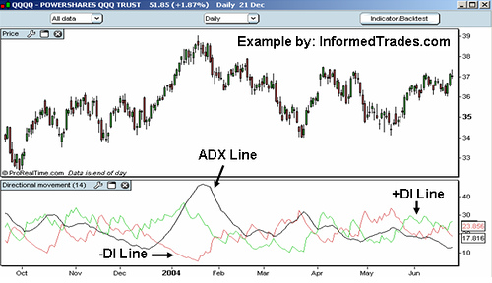
I am not going to go into the formulas for the Indicator here however you do need to know that:
- The DI Line is representative of how strong or weak the uptrend in the market is.
- The –DI line is representative of how strong or weak the downtrend in the market is.
- As the ADX line is comprised of both the DI Line and the –DI Line, it does not indicate whether the trend is up or down, but simply the strength of the overall trend in the market.
If you would like a deeper explanation of the computation of the indicator you can find it here: ADX Indicator
As the ADX Line is Non Directional, it does not tell you whether the market is in an uptrend or a downtrend (you must look to price or the DI/-DI Lines for this) but simply how strong or weak the trend in the financial instrument you are analyzing is. When the ADX line is above 40 and rising this is indicative of a strong trend, and when the ADX line is below 20 and falling this is indicative of a ranging market.
Example
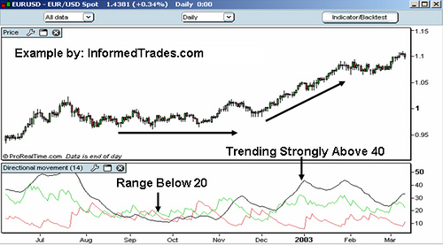
So one of the first ways traders will use the ADX in their trading is as a confirmation of whether or not a financial instrument is trending, and to avoid choppy periods in the market where many find it harder to make money. In addition to a situation where the ADX line trending below 20, the developer of the indicator recommends not trading a trend based strategy when the ADX line is below both the DI Line and the –DI Line.
Example
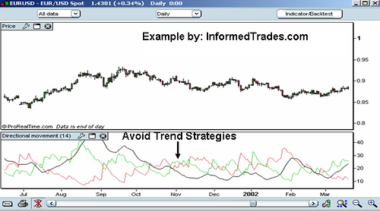
Another way that traders use this indicator is to identify the potential start of a new trend in the market. Very simply here they will look from below the 20 line to above the 20 line as a signal that the market may be beginning a new trend. The longer the market has been ranging, the greater the weight that most traders will give this signal
Example
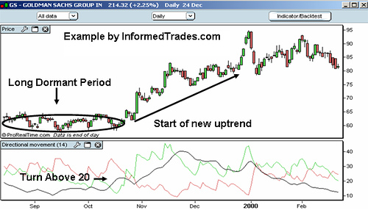
Another way traders use the ADX is as a signal of trend reversals. When the ADX is trading above both the DI line and the –DI line and then turns lower this is often a signal that the current trend in the market is reversing and traders will position themselves accordingly:
Example
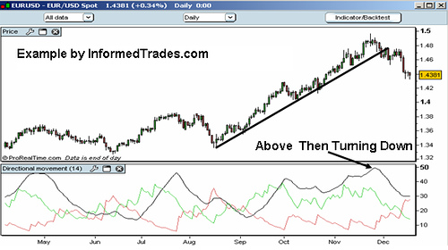
The final example that I am going to cover on how traders use the ADX is to position to trade long when the DI crosses above the –DI (as this is a sign that the buyers are winning out over the sellers) and to position to trade short when the DI line crosses below the –DI (as this is a sign that the sellers are winning over the buyers). As with the other crossover strategies that we have covered used alone, the DI crossover is prone to many false signals.
Example
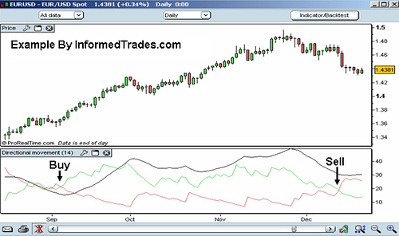
That completes our lesson for today. You should now have a good understanding of the ADX and several different ways that traders use this in their trading. In tomorrow’s lesson we are going to look at a new indicator which is called The Parabolic SAR, which many traders use to set stops when trading trends in the market.

Lesson 10: Parabolic SAR
In our last lesson we learned about the Average Directional Index (ADX) an indicator which helps traders determine the strength of trends in the market. In today’s lesson we are going to look at another indicator called the Parabolic Stop and Reversal (Parabolic SAR), which helps traders enter and manage positions when trading those trends.
The Parabolic SAR is an indicator that, like Bollinger Bands is plotted on price, the general idea of which is to buy into up trends when the indicator is below price, and sell into down trends when the indicator is above price. Once traders are in positions the indicator also assists in managing the position by providing guidance as to how one should trail their stop.
Example of the Parabolic SAR
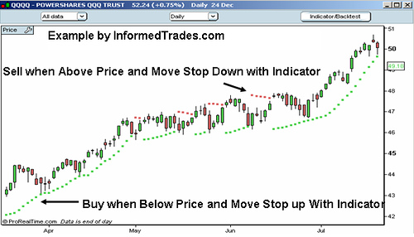
While this is an indicator that works very well in trending markets, as you can see from the below chart simply following the basic be long when the indicator is below price and be short when the indicator is above price will lead to many whipsaws in range bound markets.
Example of Whipsaws in Range Bound Markets
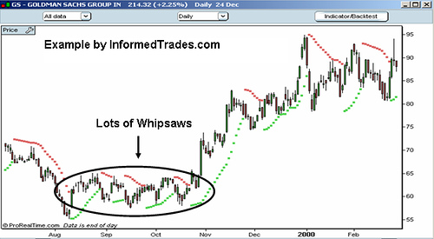
To combat this problem the developer of the indicator J. Welles Wilder (who also developed the RSI and ADX) recommended establishing the strength and direction of the trend first through the use of things such as the ADX, and then using the Parabolic SAR to trade that trend. As mentioned above although the Parabolic SAR is used for both entering and managing positions, it is used far more to set stops once in a position.
As with the other indicators we have covered in past lessons it is recommended to use this indicator in conjunction with other methods of analysis for confirmation not only on trade entry but also on trade exit.
Example:
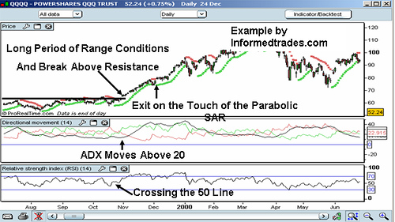
That’s our lesson for today. While my lessons are by no means exhaustive on the subject this also concludes my series on technical indicators. In our next lesson we will begin a new series by taking a deeper look at candlestick chart patterns and how one can use these in their trading.

