Lesson 1: Double Top and Double Bottom
Now that we have learned the basics of technical analysis and multi time frame analysis the next thing we will look at is chart patterns in the forex, futures and stock markets. Chart patterns are what technical traders look for on historical price charts to help them determine what the current supply and demand forces are, and how prices may be affected as a result.
In our previous lessons on trends and
support and resistance, we have already identified several of the most basic chart patterns which traders use to place trades. As you remember from these lessons, some of the more common patterns are up trends (bullish pattern), which when we view on a chart we identify with a potential buying opportunity, and down trends (bearish pattern), which we identify as potential selling opportunities.
Although support and resistance are not classified as chart patterns there are many chart patterns which are associated with identifying support and resistance, and we will start by examining the most basic of these patterns.
Double Tops:
A double top is a reversal chart pattern which is defined by a chart where a financial instrument makes a run up to a particular level, then drops back from that level, then makes a second run at that level, and then finally drops back off again.
Currency Chart Example of a Double Top:
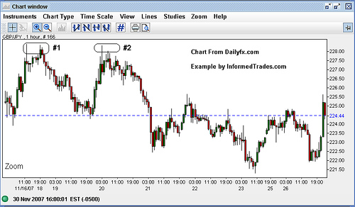
In its most basic sense what the double top pattern is saying about supply and demand forces is that demand is out pacing supply (buyers are winning) up to the first top causing prices to rise, and then the equation flips and demand is no longer out pacing supply (sellers are winning) causing prices to fall. After then falling back the buyers make another run at the same price and then after failing to break that level for a second time, sellers take control and keep the upper hand causing prices to sell of even more dramatically after the second top than they did after the first. For double bottoms the reverse is true.
A double bottom is also a reversal pattern in the futures, forex, or stock markets which is the exact opposite of a double top. To form a double bottom a financial instrument makes a run down to a particular level, then trades up from that level then makes a second run down to at or near the same level as the first bottom, and then finally trades back up again
Chart Example of a Double Bottom:
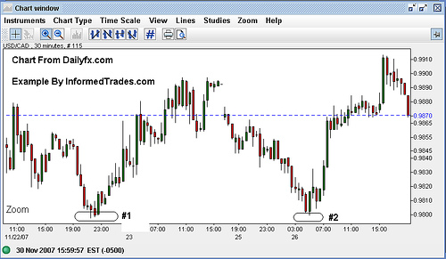
You can also see the connection here between the double top and double bottom pattern, and support and resistance as the double top forms resistance and the double bottom forms support.
Double Top Forms Resistance:
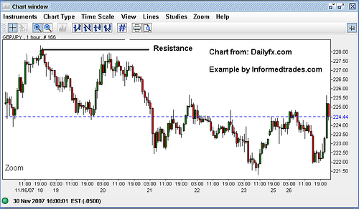
Double Bottom Forms Support:
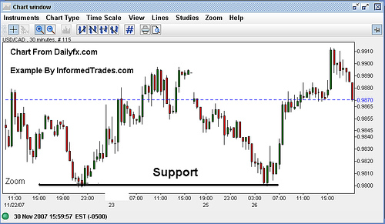
That completes our lesson for today. You should now have a good understanding of the basics of chart patterns and of two of the more common patterns, double tops and double bottoms and most likely have already started to think about how one might integrate these into their trading strategy. In tomorrow's lesson we will go over the exact details of a common strategy used to trade double tops and double bottoms in the stock, futures and forex markets.

Lesson 2: Trading the Double Top and Double Bottom
In our last lesson we learned about the double top and double bottom and how to spot these setups on a stock chart. In this lesson we are going to learn about a common trading strategy that traders use to trade these setups in the futures, forex, and stock markets.
As the double top and double bottom are signs that a financial instrument has failed to break through a certain level (resistance for a double top and support for a double bottom) these chart patterns are considered reversal patterns. As this is the case, traders will commonly look to trade the double top when it occurs at the top of a trend as a sign that the uptrend is reversing, and to trade the double bottom at the bottom of the trend as a sign the downtrend is reversing.
First lets look at the a common trading strategy for the double top. For confirmation that a double top has actually formed and that a reversal in the uptrend is at hand, a common strategy is to look for declining volume going into the second peak and rising volume on a break below the bottom of the trough which has formed between the two peaks (support).
Once these things line up a common trading strategy is to enter the trade on the break of support with a target which is equal to the distance between the bottom of the trough and the top of the two peaks projected downward from the bottom of the trough. The stop order is then placed just above the last peak.
Double Top Example:
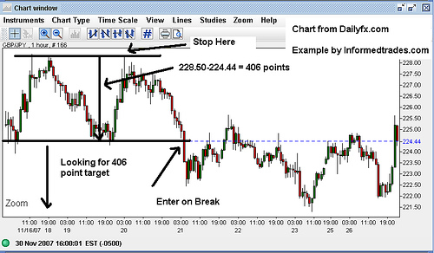
For double bottoms the process is a mirror image of the above explanation. The strategy here is to look for declining volume going into the second trough and rising volume on the break of the peak which has formed between the two troughs (resistance). Once you spot the double bottom the trade is entered on the break of resistance with a target which is equal to the distance between the top of the peak and the bottom of the two troughs projected upward. The stop order is then placed just above the last trough.
Double Bottom Example:
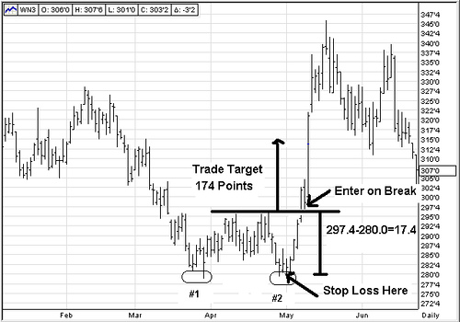
We should now have a good understanding of a common strategy used to trade double tops and double bottoms. In or next lessons we are going to look at another common chart pattern which is known as the head and shoulders pattern and a common trading strategy which is used to trade this chart pattern.

Lesson 3: The Head and Shoulders Pattern
As we have learned in previous lessons, double tops and double bottoms are forex, futures and stock chart patterns which show that the momentum needed to break a specific level of resistance for the double top and support for the double bottom is not there. When these patterns show up on a stock, futures or forex chart day traders will look for a reversal of the current trend.
In this lesson we are going to look at a chart pattern which also shows that the momentum needed to break a support or resistance level is slowing which is known as the head and shoulders pattern and the reverse head and shoulders pattern. Once we have a sound understanding of how to spot these patterns we will then look at a specific strategy for trading these patterns when they appear on a chart.
A Head and Shoulders pattern is defined by one peak, followed by a higher peak, which is then followed by a lower peak, and finally a break below the support level established by the two troughs formed by the pattern.
Head
Head and Shoulders Example:
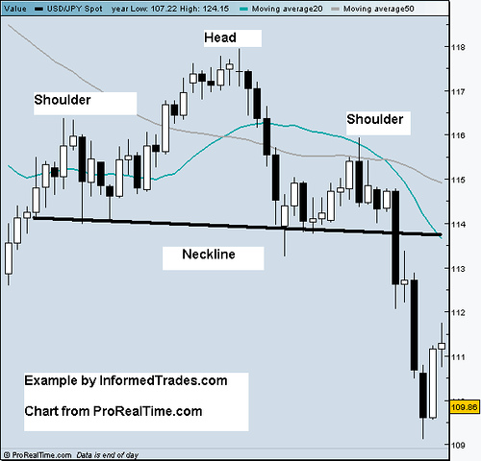
As you can see from the above chart a head and shoulders pattern is basically showing the buyers trying 3 times unsuccessfully to take the market higher before finally giving way to the sellers who theoretically retain control after the 3rd failure. The head and shoulders pattern is thus seen as a potential reversal pattern and day traders will pay special attention to this pattern when it occurs on an uptrend, and will look to trade a potential reversal of the uptrend should the pattern play out. For further confirmation that the potential for a reversal is high traders often give more credibility to a falling neckline than they do a rising neckline.
The reverse head and shoulders is basically a mirror image of the head and shoulders pattern and is defined by one trough, followed by a second lower trough, which is then followed by a third higher trough, and then finally a break above the resistance level established by the two peaks formed by the pattern.
Reverse Head and Shoulders Example:
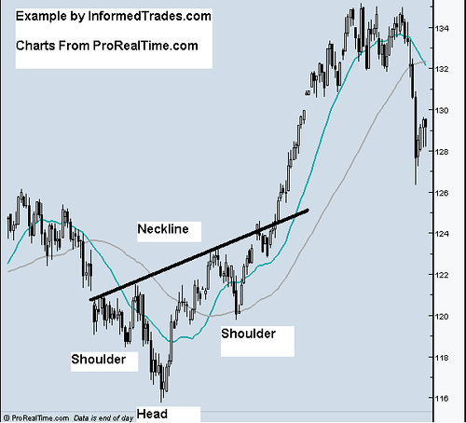
As you can see from the above chart, the reverse head and shoulders is basically showing the sellers trying 3 times unsuccessfully to take the market lower before finally giving into the buyers who theoretically retain control after the 3rd failure. Like the Head and Shoulders Pattern, the Reverse Head and Shoulders is seen as a reversal pattern, and traders of the stock, futures and forex markets will pay special attention to this pattern when it occurs as part of a downtrend should the pattern play out. For further confirmation that the potential for a reversal is high, day traders will look for a rising neckline.
You should now have a good understanding of Head and Shoulders Patterns and Reverse Head and Shoulders patterns. In our next lesson we are going to look at a specific strategy which traders commonly use to trade the head and shoulders and reverse head and shoulders complete with how to determine exact entry and exit points.

Lesson 4: Trading the Head and Shoulders Pattern
In our last lesson we learned how to spot a head and shoulders pattern and a reverse head and shoulders pattern in the forex, futures, and stock markets. In this lesson we are going to look at a specific strategy that many traders use to trade these patterns.
Upon the break of the neckline support level the chart pattern is said to be in place so this is where traders will commonly look to enter a short position. Their target will be calculated by measuring the distance from the head of the pattern down to the neckline and then projecting that distance downward from the breakpoint of the neckline. The stop will then be placed just above the right hand shoulder of the pattern which is considered resistance. The idea here is that once the neckline support has been broken sellers will theoretically remain in control but if this does not happen then you are protected with a stop loss just above the nearest resistance level.
Example of the Head and Shoulders Strategy:
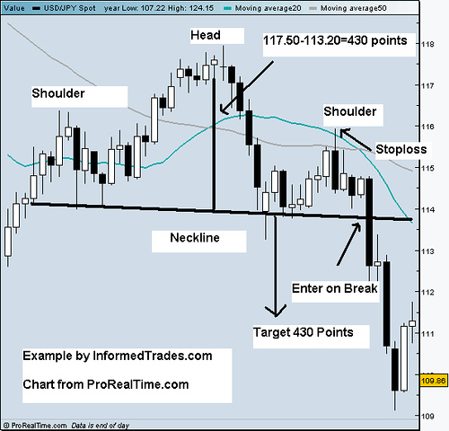
For the reverse head and shoulders the strategy is a mirror image of the above. Upon the break of the neckline resistance the pattern is said to be in place so traders will commonly look to buy at this level. Just as with the head and shoulders their target will be calculated by measuring the distance between the head and the neckline but in this case the target is projected upward from the break point of the neckline. The stop will then be placed just above the right had shoulder of the pattern which is in this case considered the nearest support level.
Example of the Reverse Head and Shoulders Strategy:
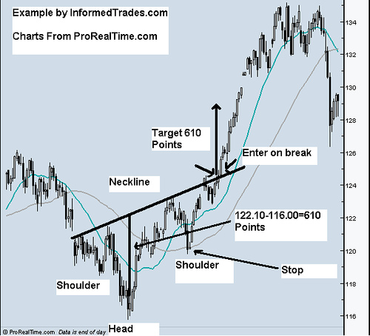
For confirmation, traders will commonly look for a downward sloping neckline before entering a trade on the break of a head and shoulders pattern and an upward sloping neckline before entering a trade on the reverse head and shoulders, as this is further indication that the trend is reversing. Secondly traders like to see the volume on the second peak (trough with a reverse head and shoulders) be lower than the volume on the first, and the volume on the third peak (trough in a reverse head and shoulders) be lower than the volume on the second peak as this is further confirmation that the trend is ready to reverse. Lastly they will look for increasing volume on the break of the neckline to show that the break is real.
That’s our lesson for today. You should now have a good understanding of the head and shoulders pattern and the reverse head and shoulders pattern as well as a trading strategy for each of them. In our next lesson we are going to finish up on reversal patterns by looking at the rising wedge and falling wedge patterns and then we will move onto continuation patterns after that.

Lesson 5: The Rising and Falling Wedge Pattern
In our last lesson we looked at specific strategies for trading the Head and Shoulders Pattern and the Reverse Head and Shoulders Pattern, two chart patterns which we view as reversal patterns when they show up in the stock, futures, or forex markets. In this lesson we are going to look at a pattern called the wedge pattern, which is unique in the sense that it can be viewed as either a reversal pattern or a continuation pattern, depending on the shape of the pattern and whether it is located in an uptrend or a downtrend.
The Falling Wedge:
The falling wedge pattern is characterized by a chart pattern which forms when the market makes lower lows and lower highs with a contracting range. When you find this pattern in a downtrend it is considered a reversal pattern as the contraction of the range indicates the downtrend is loosing steam. When you find this pattern in an uptend it is considered a bullish pattern as the market range becomes narrower into the correction indicating that it is running out of steam and the resumption of the uptrend is in the making.
Example of the Falling Wedge Reversal:
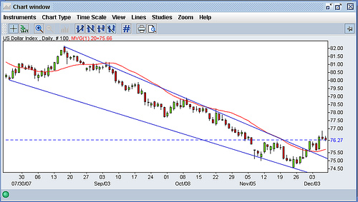
Example of the Falling Wedge Continuation:
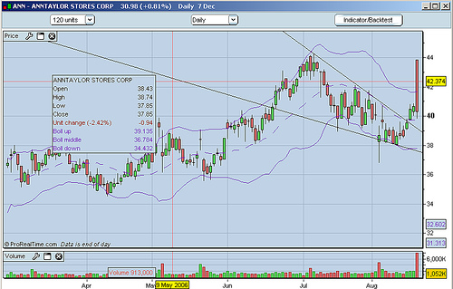
The Rising Wedge:
The rising wedge pattern is characterized by a chart pattern which forms when the market makes higher highs and higher lows with a contracting range. When you find this pattern in an uptrend it is considered a reversal pattern as the contraction of the range indicates that the uptrend is loosing steam. When you find this pattern in a downtrend it is considered a bullish pattern as the market range becomes narrower into the correction indicating that it is running out of steam and the resumption of the downtrend is in the making.
Example of the Rising Wedge Reversal:
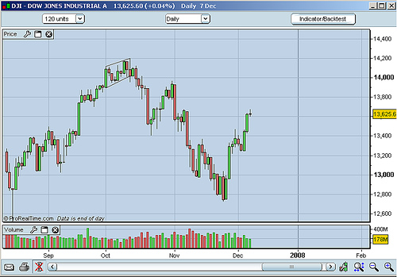
Example of the Rising Wedge Continuation:
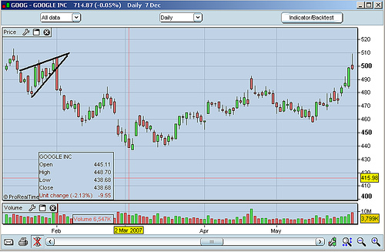
That’s our lesson for today. You should now have a good understanding of the falling and rising wedge pattern and situations where they are considered a reversal pattern and situations where they are considered a continuation pattern. In our next lesson we are going to go over a strategy for trading rising and falling wedge patterns complete with entry and exit points and how to determine each.

Lesson 6: Trading the Rising and Falling Wedge Pattern
In our last lesson we learned about the falling wedge and the rising wedge patterns, two chart patterns which can be seen as reversal or continuation patterns depending on whether they appear in an uptrend or a downtrend. In this lesson we are going to learn a trading strategy traders of the stock, futures, and forex markets commonly use to trade these chart patterns.
The Falling Wedge Reversal Strategy:
As you hopefully remember from our last lesson when a falling wedge appears in a downtrend it is considered a reversal pattern. As this is the case when traders see this pattern occur in a downtrend they commonly look to trade a reversal of that downtrend so they are looking for buying opportunities. The buy point they will commonly use is the breakpoint of the upper resistance line as this is seen as a potential confirmation that the downtrend is reversing. The target for the trade is then calculated by measuring the distance from the highest peak on the pattern to the lowest trough, projected upward from the beak point. Lastly, the stop loss is placed just below the outside of the wedge formation.
Example of the Falling Wedge Reversal Strategy:
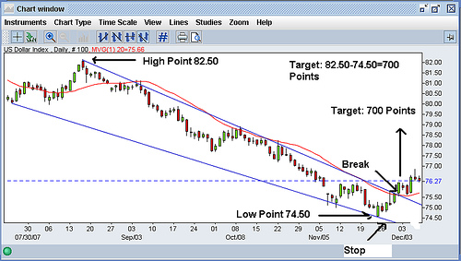
When a falling wedge appears in an uptrend, this is seen as a potential continuation pattern. As this is the case when traders see this pattern occur in an uptrend in the forex, futures, or stock market, they will commonly look to trade in the direction of the prevailing trend. The buy point they will use here as well is the breakpoint of the upper resistance line as this is seen as a potential confirmation of the continuation of the prevailing uptrend. The target for the trade is then calculated by measuring the distance from the highest peak on the pattern to the lowest trough, projected upward from the breakpoint. Lastly, the stop loss is placed just below the outside of the wedge pattern.
Example of the Falling Wedge Continuation Strategy:
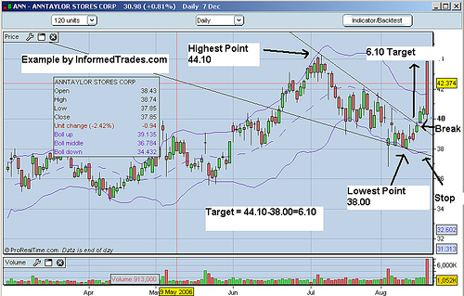
As you also hopefully remember from our last lesson, when a rising wedge appears in an uptrend this is considered a reversal pattern. As this is the case when traders see this pattern occur in an uptrend, they will commonly position to trade the reversal of that uptrend by looking for selling. The sell point they will commonly use is the breakpoint of the bottom support line as this is seen as confirmation the uptrend is reversing. The target for the trade is then calculated by measuring the distance from the lowest trough on the pattern to the highest peak, projected downward from the breakpoint. Lastly, the stop loss is then placed just above the outside of the wedge pattern.
Example of a Rising Wedge Reversal Strategy:
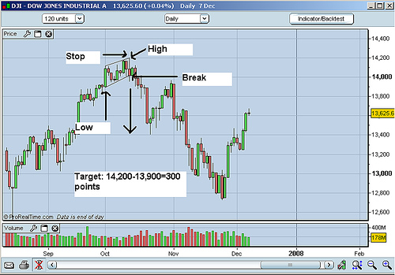
When a rising wedge appears in a down trend in the forex, futures, or stock market, it is considered a continuation pattern. As this is the case when traders see this pattern occur in a downtrend they will commonly look to trade the continuation of that downtrend by looking for selling opportunities on the break of the lower support line. The target for the trade is then calculated by measuring the distance from the lowest trough on the pattern to the highest peak, projected downward from the breakpoint. Lastly, the stop loss for this strategy is then placed just above the outside of the wedge pattern.
Example of a Rising Wedge Continuation Strategy:
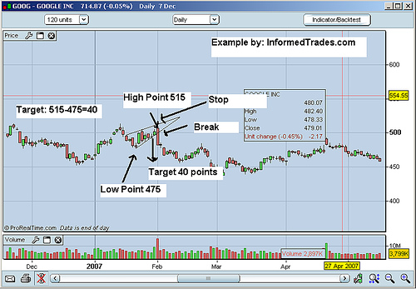
That concludes our lesson. You should now have a good understanding of how to trade both the falling wedge and rising wedge pattern. In our next lesson we will start looking at continuation patterns beginning with the Flag and Pennant chart patterns.

Lesson 7: The Flag and Pennant Patterns
In our last lesson we looked at strategies for trading the rising wedge pattern and falling wedge pattern in the stock, futures, and forex market. In this lesson we are going to start our series on continuation patterns with two chart patterns known as Flags and Pennants.
Typically seen after a big move in one direction in a particular financial instrument, flags and pennants represent brief consolidations or pauses in the market before a resumption of the trend in which they occurred. The flag and pennant patterns both contain a “flagpole” which is represented by the sharp move upwards or downwards, and then the flag portion of the pattern which forms when there is a consolidation which can be encompassed with a rectangle, or a pennant portion of the pattern which forms when there is a consolidation which can be encompassed by a symmetrical triangle.
When a flag or pennant occurs in an uptrend, a break of the top resistance line can be seen as a resumption of the uptrend. Conversely when a flag or pennant occurs in a downtrend a break of the bottom support line can be seen as a resumption of the downtrend.
Flag Patterns:
As you can see in the below example the flag portion of the bull flag pattern is encompassed by two parallel lines. These lines can be either flat or pointed downward representing the consolidation in the market. The pole is then formed by a line which represents the move big move upward which sets up the bull Flag. The pattern is seen as the market potentially just taking a “breather” after a big move before continuing its move upward and is thus referred to as a bullish pattern.
Example of a Bull Flag:
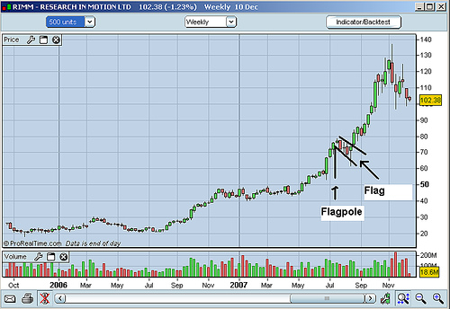
The bear flag occurs in down trends and is exactly the same pattern as the bull flag, simply flipped upside down. The lines which form the flag can be either flat or pointed upward, and the pole of the pattern is then formed by a line encompassing the move downward which sets up the bear flag consolidation. The pattern is seen as the market potentially just taking a “breather” after a big move downward before continuing its move downward and is therefore referred to as a bearish pattern.
Example of a Bear Flag:
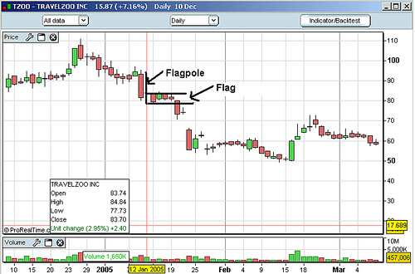
Pennant Patterns:
Similar to a flag, a pennant pattern forms when the consolidation in the market narrows as it matures requiring a more triangular shape to encompass the move instead of a square shape which forms the flag pattern.
Example of a Bull Pennant:
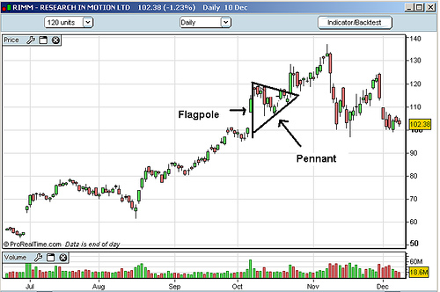
Just as with the Bull Flag the pennant portion of the pattern can be either pointed straight ahead or downward and the pole is formed by the move upward which sets up the pennant shaped consolidation.
Example of a Bear Pennant:
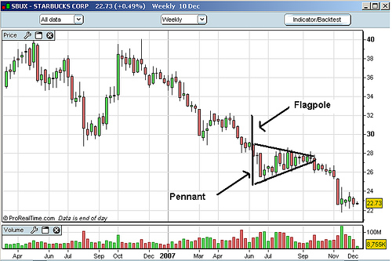
Just as with the Bear Flag the pennant portion of the pattern can be either pointed straight ahead or upward, and the pole Is formed by the move downward which sets up the pennant shaped consolidation.
That’s our lesson for today. You should now have a good understanding of flags and pennants and the difference between the bull and bear versions of each. In our next lesson we are going to look at specific strategies for trading the flag and pennant patterns, complete with entry and exit points so we hope to see you in that lesson.

Lesson 8: Trading The Flag and Pennant Patterns
In our last lesson we learned about the flag and pennant chart patterns, how to identify them on a chart, and when the pattern is a bullish or bearish sign. In this lesson we are going to learn how to identify entry and exit points for potential trades after spotting these patterns on a chart.
As we learned in our last lesson when you spot a flag pattern in an uptrend this is a bullish sign as the market consolidation which forms the flag is seen as a pause before a resumption of the original uptrend. As this is the case when traders spot these patterns on a chart they will commonly look to enter a buy position. The entry point which they will commonly use to enter the long position is the breakpoint of the upper line of the flag which is resistance. The target for the trade is then calculated by measuring the distance between the start of the up move and the highest point on the flag and then projecting that upwards. The stop is then placed just below the bottom support line of the flag.
Example of the Bull Flag Trading Strategy:
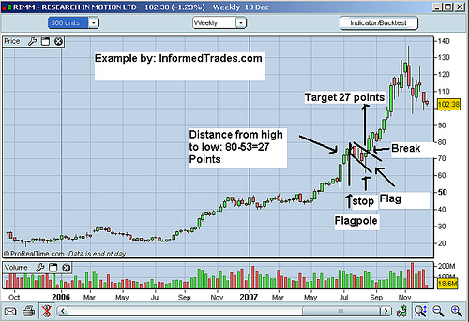
The strategy is exactly the same for the bull pennant, with one exception. When trading the bull pennant the stop loss is placed just below the bottom trend line, in line with the closest trough.
Example of the Bull Pennant Trading Strategy:
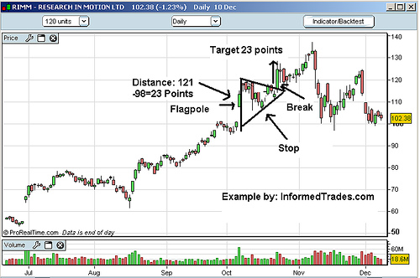
When you spot a flag pattern in a downtrend it is a bearish sign as the market consolidation which forms the pattern is seen as a pause before a continuation of the original downtrend. As this is the case when traders spot this pattern on a chart they will commonly look to enter a short position. The entry point that is normally used when trading this strategy is to sell on a break below the bottom support line. The target is then calculated by measuring the distance between the start of the down move and the lowest point on the flag and then projecting that downwards. The stop is then placed just above the upper resistance line of the flag.
Example of the Bear Flag Trading Strategy:
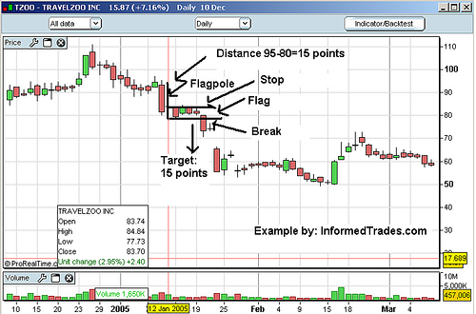
The strategy is exactly the same for a bear pennant, with one exception. When trading the bear pennant the stop loss is placed just above the upper trend line, in line with the closest peak.
Example of the Bear Pennant Trading Strategy:
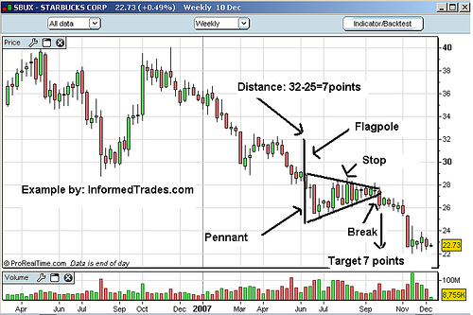
So that completes this lesson. You should now have a good understanding of the strategies used to trade flag and pennant patterns as well as how to identify these patterns on a chart. In our next lesson we are going to look at the triangle chart pattern and how to spot this on a chart so we can look at ways to trade that continuation pattern. So we hope to see you in that lesson.

Lesson 9: Triangle Charting Patterns
In our last lesson we learned strategies for trading the flag and pennant chart patterns. In this lesson we are going to look at a pattern which is similar in nature to the flag and pennant pattern which is called the triangle pattern.
Triangle Patterns can be broken down into three categories: The ascending triangle, the descending triangle, and the symmetrical triangle. While the shape of the triangle is significant of more importance is the direction that the market moves when it breaks out of the triangle. Lastly, while triangles can sometimes be reversal patterns they are normally seen as continuation patterns.
The Ascending Triangle:
The ascending triangle is formed when the market makes higher lows and the same level highs. These patterns are normally seen in an uptrend and viewed as a continuation pattern as the bulls gain more and more control running up to the top resistance line of the pattern. While you normally will see this pattern form in an uptrend if you do see it in a downtrend it should be paid attention to as it can act as a powerful reversal signal.
Ascending Triangle Example:
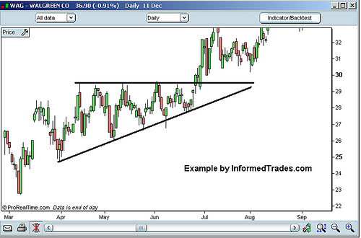
The Descending Triangle:
The descending triangle is formed when the market makes lower highs and the same level lows. These patterns are normally seen in a downtrend and viewed as a continuation pattern as the bears gain more and more control running down to the bottom support line of the pattern. While you normally will see this pattern form in a downtrend, if you do see it in an uptrend it should be paid attention to as it can act as a powerful reversal signal.
Descending Triangle Example:
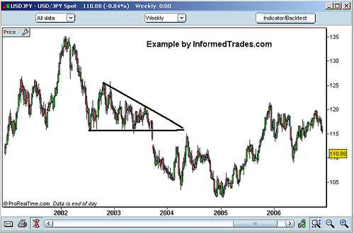
The Symmetrical Triangle:
The symmetrical triangle is formed when the market makes lower highs and higher lows and is commonly associated with directionless markets as the contraction of the market range indicates that neither the bulls nor the bears are in control. If this pattern forms in an uptrend then it is considered a continuation pattern if the market breaks out to the upside and a reversal pattern if the market breaks to the downside. Similarly if the pattern forms in a downtrend it is considered a continuation pattern if the market breaks out to the downside and a reversal pattern if the market breaks to the upside.
Symmetrical Triangle Example:
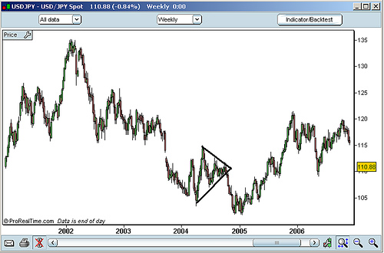
So that completes this lesson. You should now have a good understanding of the different types of patterns patterns and what each signifies. In our next lesson we are going to go over strategies for trading triangle chart patterns of these patterns complete with entry and exit points so we hope to see you in that lesson.

Lesson 10: Trading Triangle Charting Patterns
In our last lesson we learned how to spot the three different types of triangles on a chart, the ascending triangle, the descending triangle, and the symmetrical triangle. In this lesson we are going to look at the strategies for trading these patterns complete with entry and exit points.
As we learned in the last lesson, the direction in which the market breaks out of the triangle, and whether the market is in an uptrend or downtrend determines whether the pattern is a continuation or a reversal pattern and therefore whether traders look to go long or short.
As with the other patterns we have recently learned about, when traders spot an ascending triangle, they will look to trade the break of the upper resistance line. The target is then derived by measuring the distance between the starting high point of the ascending triangle with the starting low point of the triangle, which is then projected upward from the breakpoint. The stop is then placed just below the most recent trough of the pattern.
The Ascending Triangle Strategy:
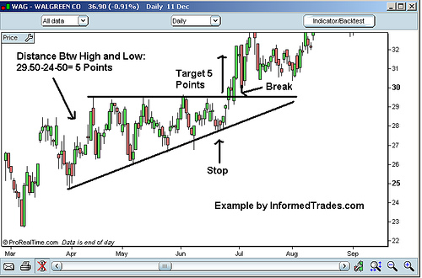
The descending triangle is the mirror image of the ascending triangle and normally seen in downtrends. When traders see this pattern they will look to trade the break of the lower support line. The target is then calculated the same way as with the ascending triangle, by measuring the distance between the high and low points at the start of the pattern and then projecting that distance downward from the break. The stop is then placed just above the nearest peak.
The Desending Triangle Strategy:
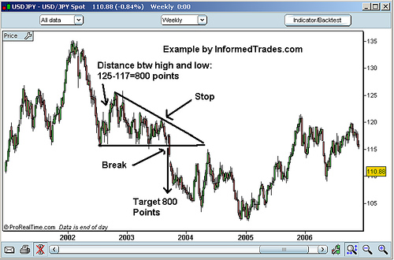
The symmetrical triangle can be seen and traded in either up trends, down trends, or sideways markets. When traders find this pattern on a chart they will look to trade in the direction of the breakout, as this is a sign that one direction either the bulls or the bears have won out over the other. Like ascending and descending triangles, traders will look to trade the break of the pattern, calculating their target by measuring the distance between the high and low at the start of the pattern. The stop will then be placed just outside of the nearest peak if the market breaks to the downside or the nearest trough if the market breaks to the upside.
The Symmetrical Triangle Strategy:
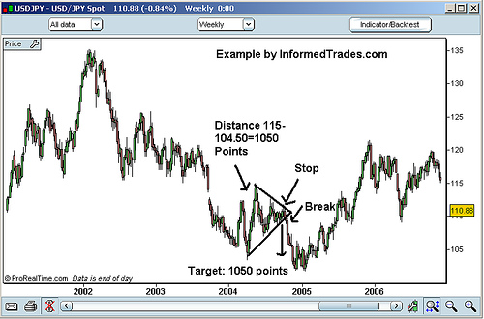
For confirmation on all three strategies, traders will look for declining volume as the pattern matures and then increasing volume on the break.
That completes our last lesson in our series on chart patterns. You should now have a good understanding of many of the most common chart patterns as well as common strategies for trading those patterns. In our next lesson we are going to start our series on learning technical indicators by looking how these tools are used in trading and how they can be used to compliment the concepts and strategies we have learned in our chart patterns lessons.

